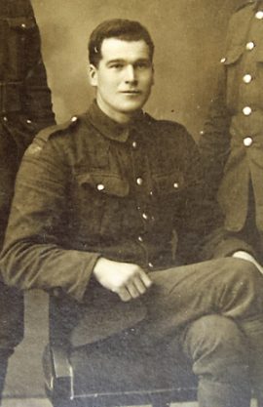

JOHN LONG MM
Helen Long’s grandfather

John Long, who was originally from Aghalee, but happened to be working in Kent at the time, enlisted on 18th June 1914, on the outbreak of war.
He joined the Royal West Kent regiment, and served throughout the duration of the war, being decorated with the Military Medal in May 1918.
He took part in much of the heavy fighting, and especially in the Battle of Amiens in August 1918, which was a significant victory for the Allies, and the beginning of the end of the war.

On demobilization he returned to Belfast and joined the RIC, and then after partition in 1922, the RUC. John became a popular figure in central Belfast in the 1920s and early 30s, as pointsman at Castle Junction. He was also on duty for the laying of the foundation stone at Stormont, when one of the dignitaries he greeted was Sir Edward Carson.
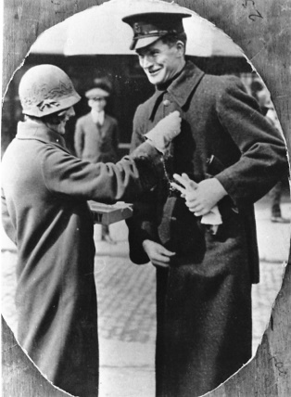
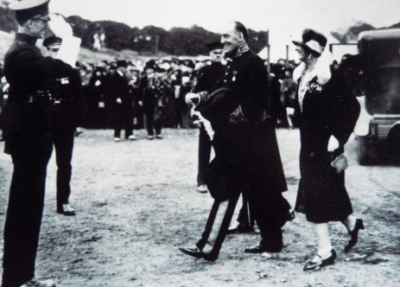

On promotion to sergeant in 1936, he was transferred to Downpatrick, with responsibility for traffic in Co Down. He and his wife Maud and two sons (the younger of whom was my father Harry) had just been settled for a few years in the town, when John died from a brain tumour in November 1940, aged 52.

The Queen’s Own (Royal West Kent Regiment)
1st Battalion
August 1914 : in Dublin. Under command of 13th Brigade in 5th Division.
15 August 1914 : landed at Le Havre. December 1917 : moved with Division to Italy. Returned to France April 1918.
7th (Service) Battalion
Formed at Maidstone on 5 September 1914 as part of K2 and came under command of 55th Brigade in 18th (Eastern) Division. Moved to Colchester in April 1915 and on to Salisbury Plain in May.
27 July 1915 :landed at Le Havre.
The history of 18th (Eastern) Division
This Division was established by the Eastern Command in September 1914, as part of the Army Orders authorising Kitchener’s Second New Army, K2. Early days were somewhat chaotic, the new volunteers having very few trained officers and NCOs to command them, no organised billets or equipment. The units of the Division initially concentrated in the Colchester area but moved in May 1915 to Salisbury Plain. King George V inspected the Division on 24 June.
Embarkation for France began on 24 July and units moved to assemble near Flesselles, completing concentration there five days later.
The Division served on the Western Front for the remainder of the war, taking part in many of the significant actions:
1916
The Battle of Albert* in which the Division captured its objectives near Montauban
The Battle of Bazentin Ridge* in which the Division captured Trones Wood
The Battle of Delville Wood*
The Battle of Thiepval Ridge*
The Battle of the Ancre Heights* in which the Division played a part in the capture of the Schwaben Redoubt and in the capture of Regina Trench
The Battle of the Ancre*
The battles marked * are phases of the Battles of the Somme 1916
1917
Operations on the Ancre (notably Miraumont and the capture of Irles)
The German retreat to the Hindenburg Line
The Third Battle of the Scarpe, a phase of the Arras offensive
The Battle of Pilkem Ridge***
The Battle of Langemarck***
First Battle of Passchendaele***
The Second Battle of Passchendaele***
The battles marked *** are phases of the Third Battles of Ypres
1918
The Battle of St Quentin+
The Battle of the Avre+
The actions of Villers-Brettoneux+
The battles marked + are phases of the First Battles of the Somme 1918
The Battle of Amiens
The Battle of Albert++ in which the Division captured the Tara and Usna hills near La Boisselle and once again captured Trones Wood
The Second Battle of Bapaume++
The battles marked ++ are phases of the Second Battles of the Somme 1918
The Battle of Epehy^
The Battle of the St Quentin Canal^
The battles marked ^ are phases of the Battles of the Hindenburg Line
The Battle of the Selle^^
The Battle of the Sambre^^
The battles marked ^^ are phases of the Final Advance in Artois
When the Armistice came into effect at 11am on 11 November 1918 the units of the Division were in XIII Corps Reserve near Le Cateau. Demobilisation began on 10 December 1918 and by 19/20 March 1919 the Division ceased to exist. In all the 18th (Eastern) Division had suffered the loss of 46503 killed, wounded and missing, of whom 13727 died and are listed in the Divisional roll of honour held at St James’s Church in Colchester.

