Matthew McKelvey

Matthew was born in 1896 his father was William and his mother was Matilda. They lived at 8 Tirgracey, Antrim Rural in the 1911 census return. He had 11 other siblings. Matthew enlisted in the 11th Service Battalion,(South Antrim) Royal Irish Rifles. This was formed in County Antrim in September 1914 from the Antrim Volunteers. It came under the orders of 108th Brigade in the 36th (Ulster) Division. It was moved to Clandeboye in December 2014.
After training it moved to Seaford near Brighton in July 1915 and then on to Boulogne in October 1915. The battalion served on the western front throughout the Great War. On the 13th November 1917 the 11th Battalion amalgamated with the 13th Bn to form the 11/13th Battalion. On the 18th February 1918 it was disbanded in France with the remaining troops going to 22nd Entrenching Battalion.

11th (Service) Battalion (South Antrim)
Formed in County Antrim in September 1914 from the Antrim Volunteers. Came under orders of 108th Brigade in 36th (Ulster) Division. Moved to Clandeboye in December 1914.
July 1915 : moved to Seaford.
October 1915 : landed at Boulogne.
13 November 1917 : amalgamated with 13th Bn to form 11/13th Bn.
18 February 1918 : disbanded in France, troops going to 22nd Entrenching Battalion.

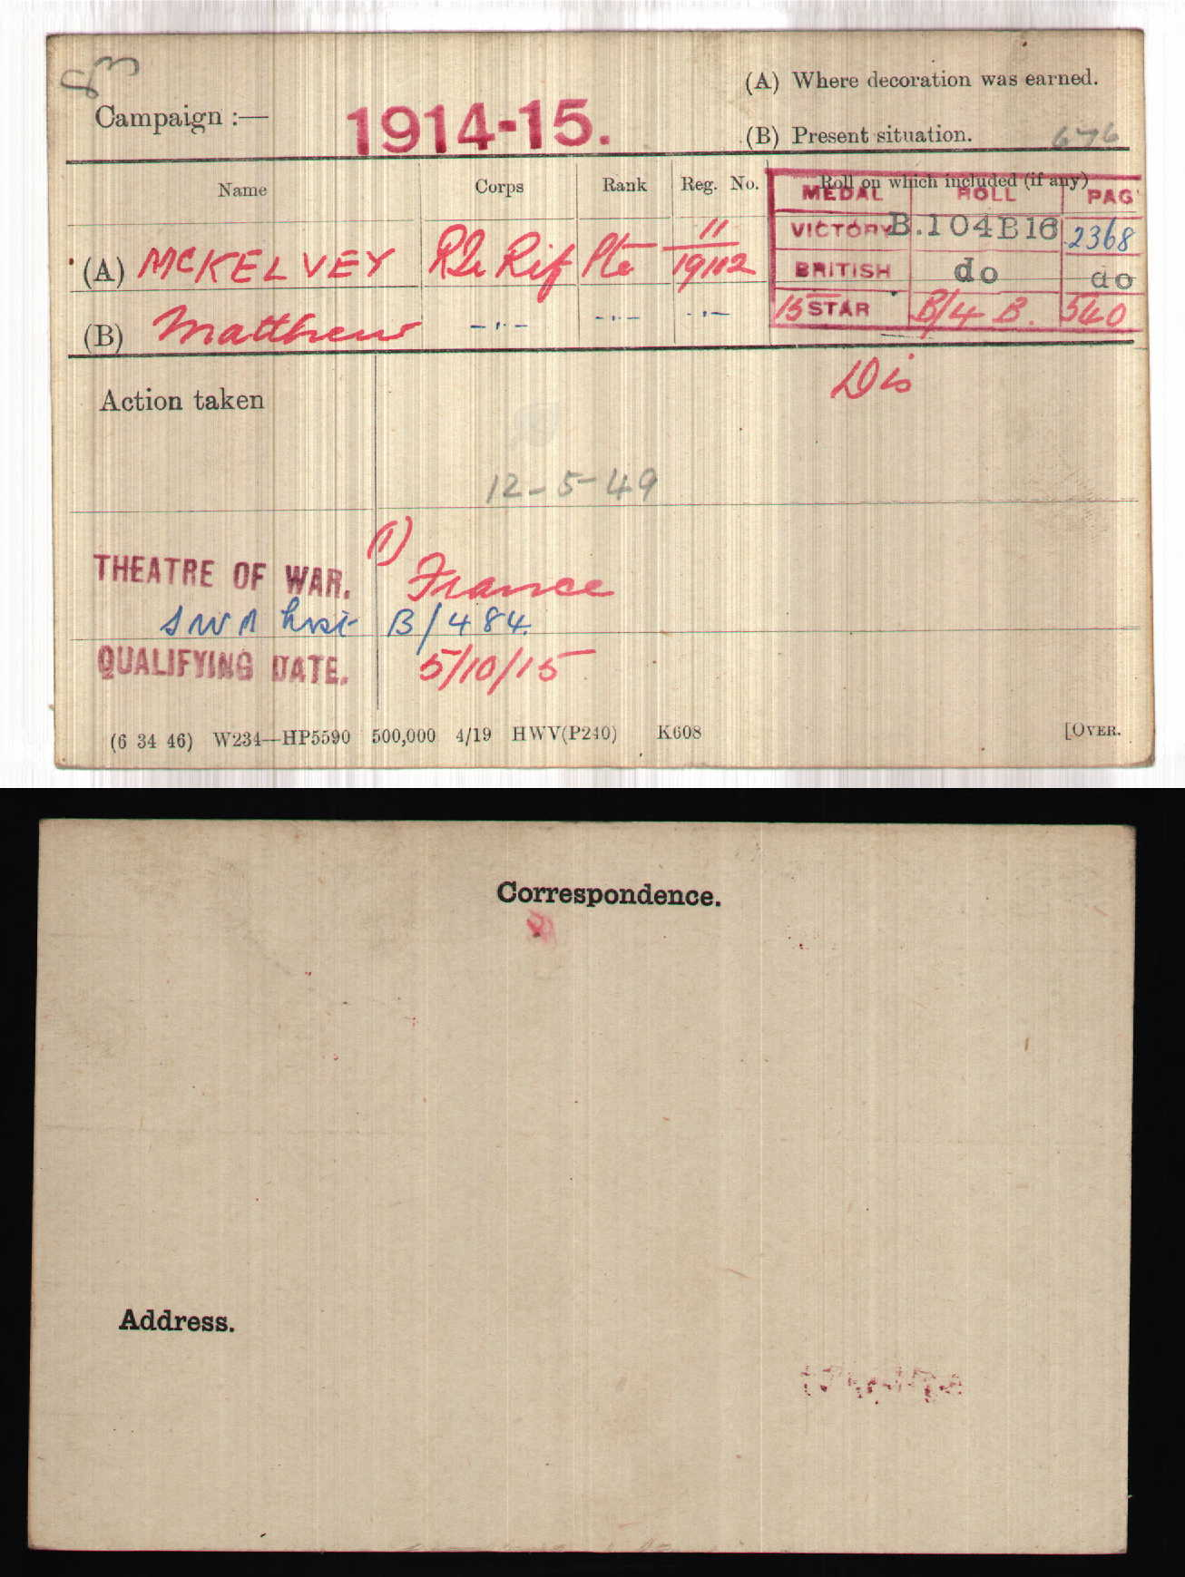

Matthew had been severely injured at the Somme and had lost ¾ of his stomach having a tube inserted which remained in place for the rest of his life.

After the war he worked in a linen mill, was married and had 1 daughter.

Matthew lived to the grand old age of 93, but never spoke of his experiences in the trenches.

11th Btn, Royal Irish Rifles, 108th Brigade, 36th Division

On 3 September 1914, just short of a month after Britain had declared war and after much discussion regarding what amounted to a political ‘truce’ with regard to domestic matters, Sir Edward Carson (one of the great political leaders opposing Home Rule for Ireland) made an appeal at the meeting of the Ulster Unionist Council in Belfast, urging the men of the Ulster Volunteer Force to come forward for service in the defence of the British Empire. Despite the fact that many Ulstermen had made their own decisions and had already enlisted, an entire formation known as the Ulster Division was soon raised – and all of its infantry units were based on existing units of the UVF. Thirteen battalions were raised for the three Irish regiments based in Ulster: the Royal Inniskilling Fusiliers, the Royal Irish Fusiliers and the Royal Irish Rifles.
1914
August: formed in Ireland as the Ulster Division, with Brigades numbered 1,2 and 3. On 28 August 1914, the Division and its Brigades adopted the titles shown on this page.
1915
July: the Division moved to Seaford on the Sussex coast of England. Lord Kitchener inspected the Division there on 27 July 1915, and later remarked to Carson “your Division of Ulstermen is the finest I have yet seen”. Another inspection took place, by King George V, on 30 September. On 3-6 October: the Division moved to France, although the artillery remained in England until November. The Ulster Division initially concentrated in the area around Flesselles, some ten miles north of Arras. Gradually, men were sent in groups for familiarisation with trench warfare conditions, and were attached to the regular army 4th Division for the purpose in the (at this time) quiet are north of the River Ancre near Albert. On 21 October the Division was moved away from the fighting area towards Abbeville, where it spent most of the winter of 1915-16 continuing training. One of the Brigades was attached to 4th Division for several weeks at this time and the artillery finally rejoined.
1916
The whole Division finally took over a complete section of the front line on 7 February, between the River Ancre and the Mailly-Maillet to Serre road. Division HQ was at Acheux. In the first week of March, the Division extended its front, the 109th Brigade taking over the sector south of the Ancre, known by the name of Thiepval Wood. The Division remained in the Wesrern Friont in France and Flanders throughout the rest of the war and took part in the following engagements. The Battle of Albert* in which the Division attacked at the Schwaben Redoubt near Thiepval overwhich the Division fought on 1st July 1916. The Division was relieved on 2 July, having suffered 5104 casualties of who approximately 2069 died.
1917
The Battle of Messines, in which the Division captured Wytschaete
The Battle of Langemarck.
The Cambrai Operations, including the capture of Bourlon Wood
1918
The Division was substantially reorganised in February 1918.
The Battle of St Quentin
The Actions at the Somme Crossings
The Battle of Rosieres
The Battle of Messines
The Battle of Bailleul
The First Battle of Kemmel Ridge
The Battle of Ypres
The Battle of Courtrai
The action of Ooteghem
On 11 November the Division was at Mouscron, north east of Tourcoing. It remained there throughout the period of demobilisation. It ceased to exist on 29 June 1919.
The Great War cost 36th (Ulster) Division 32186 men killed, wounded or missing.

