Ernest Charles Ormond

When Ernest Charles Ormond (known as Charles) was born on 24th Oct in Calcutta, Western Bengal, India, his father, Ernest William, was 33 and his mother, Elinor Pugh, was 23. He married Nancy Edith Magor in December 1930 in Chelmsford, Essex. They had 3 children during their marriage. He died in Surrey on 8th September 1962 at the age of 65. He served in the British Army Royal Field Artillery from 1915 to 1918 (perhaps longer as mention of him being in Mesopotamia in 1921). He was wounded in the leg during the Battle of the Somme (see photo of him convalescing back home in Wales with his mother 1916) but returned to active service in 1917-18. After the war he went to study at Cambridge University and then went to Calcutta in 1926. There he practiced initially as a barrister and eventually as a High Court Judge in post-independence Pakistan. He retired due to ill health in 1956 and returned to England.
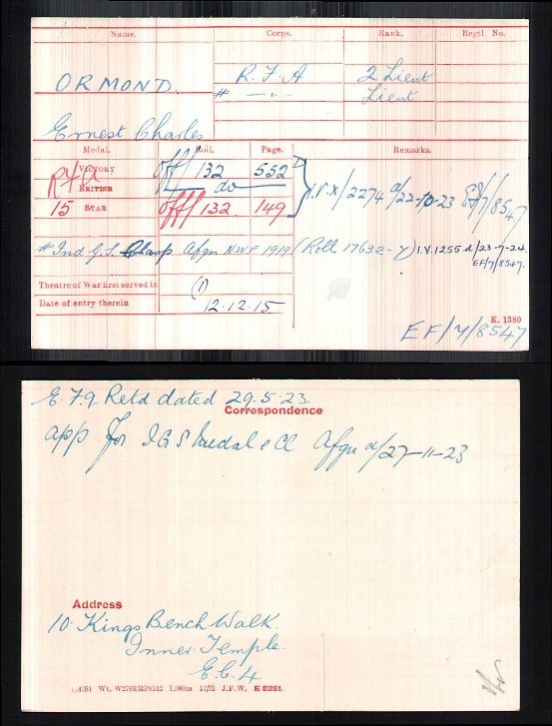
CHARLES ORMOND’S LETTERS FROM THE WESTERN FRONT DEC 1915-JULY 1916 TO HIS MOTHER
These were passed on by Charles’ daughter, Roessa who said that there was no reference to his injuries.
26.1.16 “ Today all the artillery of the Division were inspected by General Goff/Gough of the Corps. We had to get up at 6 a.m. and have the whole battery on the road by 8 a.m. …when you remember we have to water, feed and groom horses, harness and hook in, besides letting the men get their breakfasts and get ready themselves you can see we had to hurry ourselves. Then when we got to the place…we had to wait hours! However I think the General and all his red hats in attendance were quite pleased with us…Tomorrow we are going on three days’ manoeuvres, possibly starting at 4 a.m. So if I do not write please put up with it.”19.2.16 (on taking over a battery) “…there are three doors and there is not one of them that does not let in a gale, besides several windows with no glass, wood, tin, celluloid (in them)…The difficulty is …that our guns shake the glass out. But I am really pleased with life for it seems a very good position for a battery and it only needs a little time to make it comfortable. Of course by far the most important thing is to have a good position for the guns. I would love some cake and now I must stop.”
3.3.16 (Writing for the benefit of his brothers about the battery position) “the four guns (without any limbers or anything else) are sat down by the side of a small road in four gun pits. Some guns are practically all below the level of the ground…made entirely by digging out: others are practically all above the ground and eventually built up with sand bags etc… when we took over the position nearly all the top sides of the gun pits were too square. Of course this is not so important at this time of year as the sun is not very strong, but if it was summer these pits would throw such sharp shadows that an aeroplane would be sure to notice them. We are rounding them off now and turfing the sides… I should think it is very hard to get guns in and out (of dug out gun pits)…and they collect all the water for miles around.
Then joining each gun pit and connected to it by a sort of tunnel is the dug out for the gun detachment….the dug outs we are making have straight walls, decent bunks for the men to sleep, wonderful chimneys and fireplaces etc. A fire in a dug out I think makes all the difference…the chimneys are only allowed to smoke after dark…The sergeant of each gun has a dug out near his gun.
We officers all have dug outs too… We might have had billets of sorts, but as one of us has to be with the guns night and day and we could not get a billet within several hundred yards, it was very inconvenient….so we had a brilliant idea and made ourselves dugouts. When I have finished (mine) it will be quite nice. I am writing there now. I have got an old bedstead and a chair so am quite well furnished! …When I can get charcoal a brazier is quite a success. When I can’t I get nearly set on fire and smoked out and the ceiling and in fact everything in the place is made artistically black. Our Mess is just across the road. Captain Coffin has a room in the same house…but he is not at all comfortable there.We have not had much time to make ourselves comfortable… At present we all eat our meals in the Mess, as it were girded and with our staves in our hands: that is to say with our warmest coats and caps on because of the draughts. (No windows yet)
Thank you and Dad for all your various letters. Also the cake which was very good. Miss Lewis sent me …a cake and pair of very nice socks…some chocolate biscuits and some sweets.”
10.3.16 “I am just about ¾ mile nearer the front line trenches than the battery. The battery is about 2,500 yards from the German front Line and I am about 1,000 to be exact. All the artillery and observing stations round here are much the same. To make an observing station you find a house from which you think you would get a good view of what you want to see. Any such house is certainly well entitled to the name of a ruin
...There is always one subaltern at the guns and one at the observing station all day. The third one either goes down to see the Infantry …or goes back to the waggon lines which are 3 or 4 miles back from the Battery…or he does any odd jobs that need to be done. For instance in my case, I am the Telephone Officer….The day we are on guns, we have to stop up until 12… after midnight the orderly sergeant carries on…Every six days our turn comes round to do Liaison Officer with the Infantry. (2 Batteries cover one Battalion)…You go up to Battalion HQ about dusk. You have dinner with them and spend the night there. It is quite interesting as you meet all sorts of different people. In every Battalion HQ there seems to be one Colonel, a second in command who should be a major, an adjutant (who may be a captain or lieutenant or anything else), an Intelligence Officer, Bombing Officer, Telephone Officer, Medical Officer…the only drawback about a Battalion HQ is that they all seem to be such night birds. They can afford to get up at a reasonable hour in the morning and so they go on messing with papers and things till past midnight. Also they have no proper place for us to sleep up in the Battalion HQ in these trenches. We have to sleep on the floor in the mess dugout. Personally, however, colonel or no colonel, I usually just put my blanket and fur sleeping bag (which by the way I could not do without now for a single night and which I get my servant to bring up whenever I go up as Liaison Officer)down on the floor.”
19-4-16 He describes the new dug out he and Alabaster are making and is especially proud that it has a brick fireplace. “It is a beastly windy day (at the OP). I hope you realise how I look forward to your letters every day and I think that one you sent me one just the other day was an especially good one: it seemed to smell of Bodtalog”
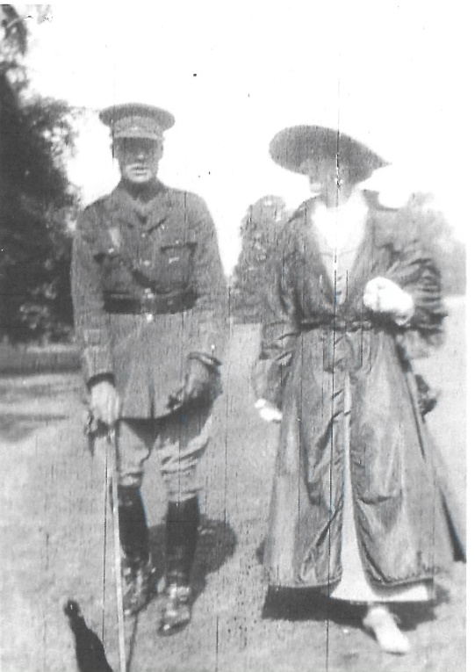
Undated, presumably mid-late June “…I thought it was a lucky thing that the French country people all got up so very early. For it is an awfully slow job getting billets when you have first to pull all the people out of bed. We got our billets all right. We also got some breakfast…coffee and bread and butter and jam and omelette and excellent cherries…Before I had finished that day I had ridden between 30 and 40 miles and walked about 10… On the morning of the 10th the brigade entrained and arrived at the station where we detrained just about 1 ½ hours before dark. HQ and Battery went in the first train, the other batteries following with about 3 hours interval between each train. The country we passed through soon became very much prettier and instead of slag heaps, mines and flat dull plough, we saw woods and hills with pasture and plough cunningly mixed and streams like trout streams with marshland and larger rivers with a wide expanse of water. As soon as the train stopped, the interpreter and I got out our horses and went straight off by map to a place (8 miles) where we were to billet for the night. We were getting billets or arranging to show people to their places all night long. To get places for artillery means firstly that you have to get places for the horses and wagons and guns to stand. There has to be water near and horse must be able to drive in and out and any bridges across ditches etc. on the way have to be strong enough to carry the weight. (Each battery has about 130 horses.)…the next thing is to find places for the men to sleep: any place with a decent roof and a dry floor – if possible with straw, is a good find. And then thirdly, you have to try to find beds for the officers. This means roughly 25 beds, or inside rooms of some sort, even if there are no beds and the officers have to sleep on the floor. And then fourthly, you have to find a mess for each of the batteries and HQ. That means places where officers can eat and where there is some sort of stove for cooking. I rather like going billeting given plenty of time and a fine day but it is rather a high flown joke in the rain, especially at night.
I found a charming little house for no. 1 billet. The owner was living in the large town nearby: this was his country cottage, but it was not shut up as he left a gardener and his wife there to look after it. It had a very pretty little garden with any amount of roses: lots of fruit coming on the wall and some of those delightful small strawberries…there were three nice little first floor bedrooms and two quite decent attic rooms and two sitting rooms with a piano and all sorts of things and a kitchen to ourselves. (The previous night’s billet had been a double cottage attached to a brewery. It was still occupied by the brewer and his family who was “very obliging” and gave up a sitting room as a mess and also his kitchen.) (The lawyer’s cottage) was a very peaceful place and I was hoping to have quite a nice quiet day and night after not having sat down for more than ¾ hour all the night of the 10th…but our dreams of rest were soon knocked on the head, as they wanted our village for some Australian Infantry and moved us next morning to another village 10 miles more west.”
We have been on the outskirts of two German gas attacks. The gas we got only lasted a few minutes and did no harm whatever as we all had our gas helmets. But for a few minutes the stuff was so thick that you could simply not see eight yards. “
Pre 26.7.16 to Mrs Kettle at Rhowniar, a long letter, explaining that they have moved…”from our old haunts…very many days ago, but we have been a regular travelling circus since then….
The first day or two here were beastly. The land had just been a battlefield and you can’t think what it all means. Our brigade lost about 60 horses, wounded etc, as well as some officers and men.
We can see so much more on our hill. Every evening the aeroplanes seem to delight in giving us an exhibition flight, while we are having supper. The other evening it was wonderful. There were six or seven machines up in the corner of the blue – all ours I think. And then in another place was a German and one of ours having a duel. They were both doing some wonderful flying: climbing and diving nose-downward…the I think our fellow must have been damaged or else he took it into his head to do the Mother Lapwing trick. Anyhow he kept climbing down lower and lower and we all thought he was done in…but the German was low down too, chasing our fellow right over our infantry. And the next thing we heard was a regular volley of rifle fire from our own infantry and the enemy machine brought down in our lines and our own sailing leisurely home…
I think the boot must be on the other foot now. I mean that what the German gunner delighted to give us at the beginning of this war in the way of artillery fire, he must now find being repaid. All the same, you must know much more of the war than we do…

