Archie Chalmers Hills

Archie Chalmers Hills was born on 14 July 1868 in Calcutta, West Bengal, India. His father Archibald was 36 and his mother Emma was 28. He married Agnes Evelyn Ferguson on 31 December 1894 in his hometown. They had one child during their marriage. He died in June 1948 in Denbighshire at the age of 79. His wife died on 24 May 1928 in Machynlleth Montgomeryshire at the age of 58. They had been married for 33 years. Archie had been a Reservist Captain in the Indian Army and served on the Western Front during the First World War. He later returned to London on the 20th April 1922 and moved to Denbighshire.
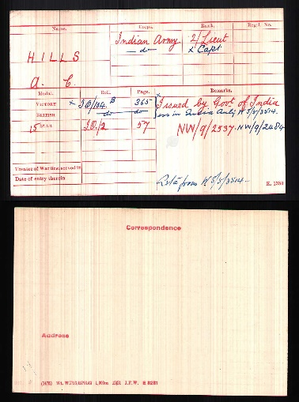
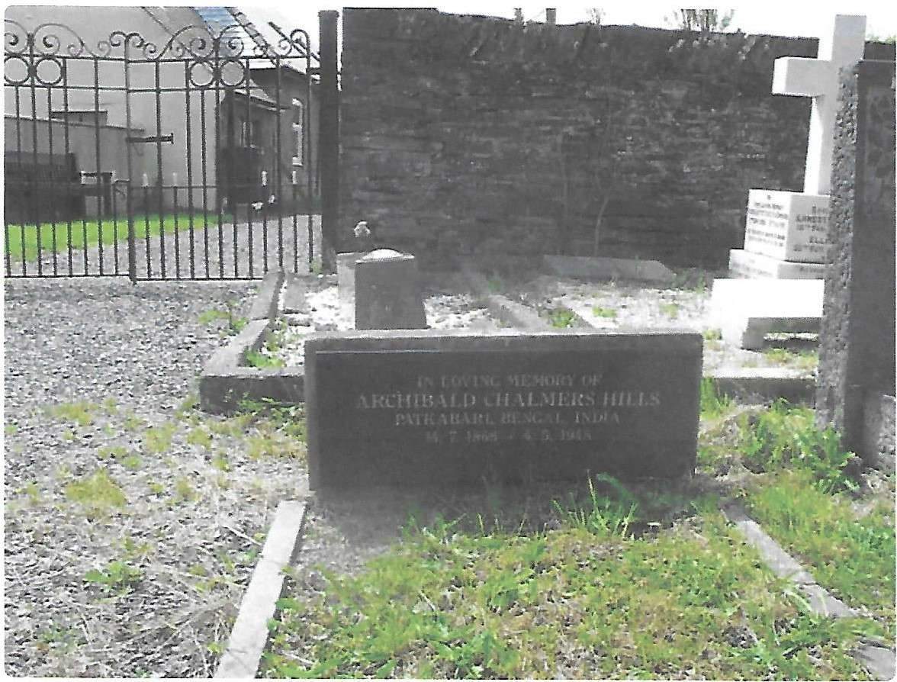

The Indian Army in 1914 and the Formation of the Indian Expeditionary Force

The Indian army was conceived of as an auxiliary force to the British army. Its mission was to assist the latter in fighting “small wars”, either campaigns on the northwest frontier of India against the Baluch and Pashtun tribal groups, or colonial expeditions to conquer new territories or repress revolts. Its total strength in 1914 was 152,000, i.e., approximately two-thirds of the strength of the British army (250,000), but it was devoid of heavy artillery, and its training emphasized combat in open terrain against a mobile enemy not equipped with artillery. It was definitely not meant to take part in a European war. With the growth of tensions in Europe, however, a plan was drawn up in 1911 that envisaged sending Indian troops to Europe, but it was shelved at the request of the British Government. When, following the disastrous Mons Retreat in early August 1914, the British Expeditionary Force to France and Belgium found itself seriously undermanned, it was decided to call on the Indian army, the only available imperial reserve force. An Indian Expeditionary Force (IEF), consisting of two infantry divisions (Meerut and Lahore) and two cavalry brigades (Ambala and Secunderabad), was hastily assembled and dispatched to Marseilles, where it disembarked on 26 September. These units formed, for operational purposes, an Indian Corps, some 45,000 strong (28,500 Indian and 16,500 British) and under the command of General James Willcocks (1857-1926), which was part of Douglas Haig’s (1861-1928) British 1st Army.

Holding the Line

The Indian sepoys had to adjust quickly to the climate of Europe and to the use of new weapons, such as the Lee-Enfield Mark III gun and the Vickers machine-gun, but they lacked proper winter clothing when they were sent to the front at the end of October 1914 to take part in the First Battle of Ypres (25 October-15 November). The Indian Corps was ordered to hold a line seventeen kilometres long, i.e., one-third of the line held by the British 1st Army, and faced severe German attacks without proper artillery cover. The first two months of combat took a heavy toll on the Indians, who had to learn a form of combat they were unused to, and sustained great losses, including that of most of their experienced British officers. Their biggest trial came in the Givenchy sector on 19-20 December: four Indian brigades launched an attack against the German lines. They gained some ground, but, in the face of the German counter-attack, could not hold and had to be relieved by British troops. The High Command decided they were so exhausted that they had to be withdrawn from the front to recuperate.
Doubts and Controversies.
At that time, serious doubts started to be voiced by some in British command, including Commander-in-Chief Sir John French (1852-1925) and 1st Army commander Douglas Haig, regarding the performance of the Indian soldiers and the value of their deployment. It was remarked that the incidence of self-inflicted wounds (mutilation of the hands) was higher in the Indian than in the British ranks, which was seen as a sign of poor morale and led to accusations of “cowardice” directed at the sepoys. Military historians have been divided in their opinions regarding the performance of the Indians. Jeremy Greenhut, an American military historian, largely echoing the views of the British High Command, was critical of their performance in an often-quoted article: he ascribed their failure to the difficulty soldiers coming from an agrarian country had in adapting to modern industrial warfare. His views have recently been criticized by British military historian George Morton Jack, who claims that the Indians were learning the basics of trench warfare, like the soldiers of all the other armies, a process that was interrupted before it could be completed, which makes an objective judgment of their performance difficult.

Towards Withdrawal

Whatever the doubts expressed by the British High Command, the Indian Corps was sent back into battle at the beginning of 1915 and took part in the battle of Neuve-Chapelle on 10-12 March 1915. It conquered some terrain against fierce German resistance, but had to withdraw due to insufficient artillery preparation. The Indian Corps took part in a few other battles: the second battle of Ypres (April 1915), and the battles of Aubers ridge (9 May) and Festubert (15-25 May). Its last intervention was in the battle of Loos (25 September-15 October 1915). At the end of October 1915, it was dissolved, having sustained total casualties of 22,000 (8,000 dead and disappeared; 14,000 wounded) and, at the end of December, the two infantry divisions (with 30,000 Indian and 4,500 British) left France for Mesopotamia, where they were immediately thrown into battle at Kut-el-Amara. 7,000 cavalry soldiers were left in France, as well as 6,000 auxiliaries. They were merged with Canadian cavalry to form a new Cavalry Corps. They remained in France until March 1918, rarely engaging in combat, and mostly used as labour to dig trenches and perform other work. In March 1918, they were dispatched to Egypt, where they joined Edmund Allenby’s (1861-1936) forces to take part in the Palestine campaign against the Turkish army.

