Frederick Valentine Russ
Army and RFC(RAF)

Frederick Valentine Russ was born on the 14th February 1885, son of Christian Carl and Emily Callaway. He married Helen Caroline Bliss on the 5th March 1910 and they had one child Frederick Basil Russ on 23rd November 1910. Two other children followed, in 1918 Rita Constance Muriel and 1920 Brenda Doris. All three children lived to old age, Frederick and Rita to 90years old and Brenda to 87 years old. Frederick himself died on 3rd May 1953 (aged 68) and his wife Helen Caroline on 10th March 1971(aged 86).
On June 21 1902, Fred entered apprenticeship at Mr Thomas Owen Cabinet Maker 18 Oldbury Place Marylebone, Premium £50, £25 on signing and £25 in 6 months repayable as wages 1st year 4/- week, 2nd year 7/- week, 3rd year 10/- week.

At the outbreak of War, Frederick, who was still living at home, volunteered for the army. He would fight in the trenches in Belgium. After his second bout of pneumonia, however, the army refused to send him back to the front, so he became a balloonist in the Royal Flying Corps. Fred was married by the start of the War. He moved from Hemel Hempstead [poultry farming] to Ealing probably close to the outbreak of the War.
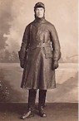

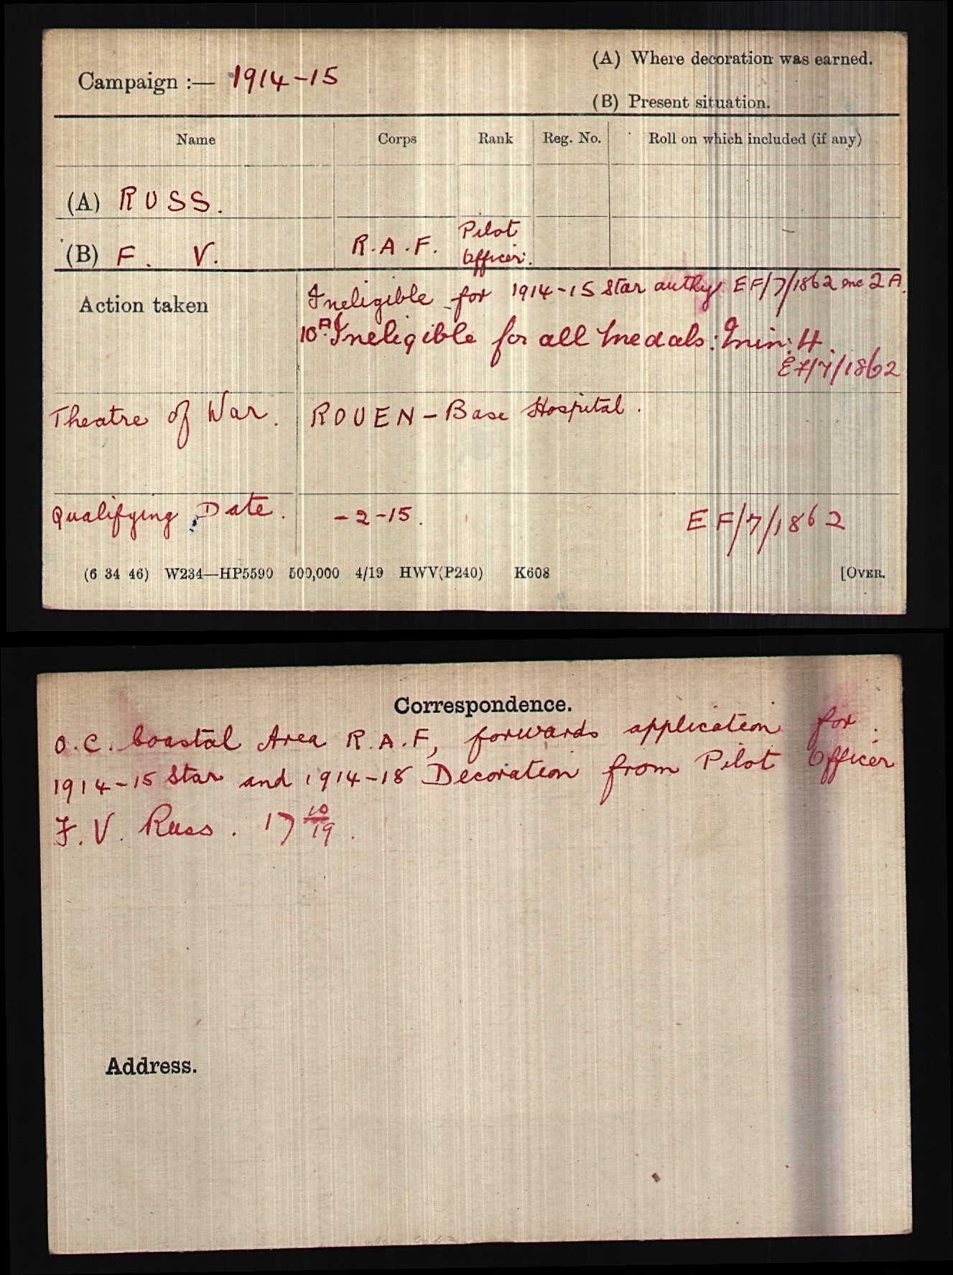

He qualified as a Pilot Officer in the Royal Flying Corps later the Inaugural Royal Air Force. Frederick Valentine Russ was employed by the Office of Works, after his discharge from the Armed Forces in 1919-20, as a technical officer. His office/department had responsibility for 'English Heritage including Wales & Scotland' and had a distinguished career in this service.

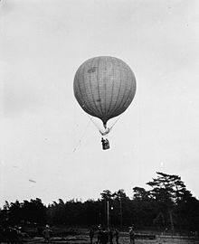
British observation balloon from 1908, typical of pre-WWI observation balloons
An observation balloon is a type of balloon that is employed as an aerial platform for intelligence gathering and artillery spotting. Use of observation balloons began during the French Revolutionary Wars, reaching their zenith during World War I, and they continue in limited use today.
Historically, observation balloons were filled with hydrogen. The balloons were fabric envelopes filled with hydrogen gas, whose flammable nature led to the destruction of hundreds of balloons on both sides. Observers manning these observation balloons frequently had to use a parachute to evacuate their balloon when it came under attack. To avoid the potentially flammable consequences of hydrogen, observation balloons after World War I were often filled with non-flammable helium.
Typically, balloons were tethered to a steel cable attached to a winch that reeled the gasbag to its desired height (usually 1,000-1,500 metres) and retrieved it at the end of an observation session
World War I was the high point for the military use of observation balloons, which were extensively deployed by both sides. Artillery had developed to the point where it was capable of engaging targets beyond the visual range of a ground-based observer. Positioning artillery observers on balloons, generally a few miles behind the front lines and at altitude, allowed them to see targets at greater range than they could on the ground. This allowed the artillery to take advantage of its increased range.
The British, despite their experience in late 1800s Africa, were behind developments and were still using spherical balloons. These were quickly replaced by more advanced types, known as kite balloons, which were aerodynamically shaped to be stable and could operate in more extreme weather conditions. The Germans first developed the Parseval-Siegsfeld type balloon, and the French soon responded with the Caquot type.
Because of their importance as observation platforms, balloons were defended by anti-aircraft guns, groups of machine guns for low altitude defence and patrolling fighter aircraft. Attacking a balloon was a risky venture but some pilots relished the challenge
World War I observation crews were the first to use parachutes, long before they were adopted by fixed wing aircrews. These were a primitive type, where the main part was in a bag suspended from the balloon, with the pilot only wearing a simple body harness around his waist, with lines from the harness attached to the main parachute in the bag. When the balloonist jumped, the main part of the parachute was pulled from the bag, with the shroud lines first, followed by the main canopy. This type of parachute was first adopted by the Germans and then later by the British and French for their observation balloon crews.

