REGINALD NOEL NICHOLSON
Reginald Noel Nicholson was born in Sheffield in 1893 to Charles and Kate Nicholson. Reginald emigrated to Natal, South Africa via London and Durban in 1912, residing at his given address of the Union Hotel, Ladysmith (image below) until 1914.
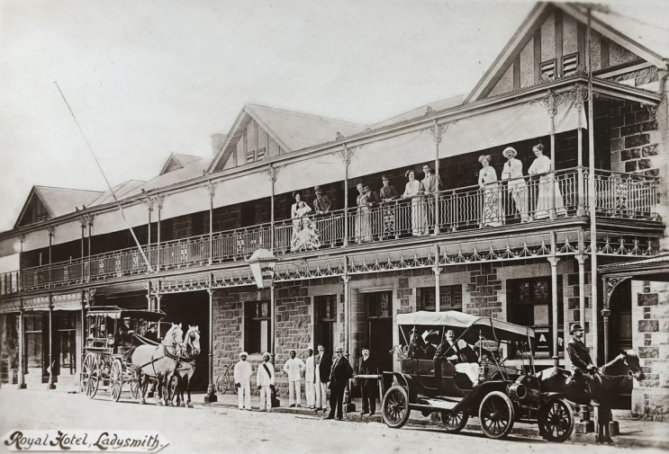
UNION HOTEL, LADYSMITH 1914 (Mole's Genealogy Blog)
At the outbreak of WWI the Union of South Africa troops were restricted, by law, to the defence of the Union of South Africa. To support Britain in its war against Germany, the South African Overseas Expeditionary Force was formed from volunteers in 1914, known as the 1st and 2nd South African Infantry Brigades.
German South West Africa (1914-1915)
At the outbreak of war, Reginald volunteered for the Natal Carbineers, then known as the 1st and 2nd Mounted Rifles forming part of the 2nd South African Infantry Brigade. He was mobilized for war service on 23 August 1914. The Mounted Rifles saw service in German South West Africa (now Namibia). The campaign in South West Africa was characterised by arduous marches over desolate desert terrain, with water supply being the primary consideration in manoeuvring and engagement between the adversaries. Pvt Nicholson was present at the climactic battle of the South African campaign in South West Africa, which was fought at Gibeon Station on 25 April 1915, forcing the surrender of the German troops.
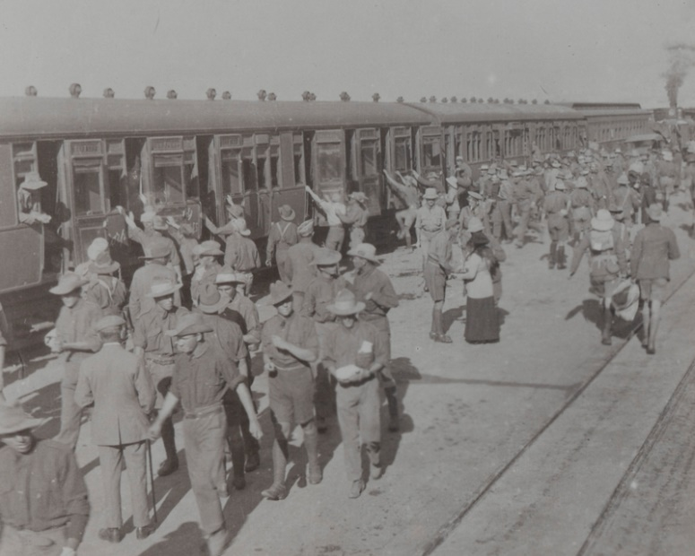
1st NATAL CARBINEERS ENTRAINING IN CAPE TOWN AFTER RETURN FROM SOUTH WEST AFRICA, 1915
(National Army Museum)
German East Africa (1916 - 18)
In 1916, General Jan Smuts mobilised a large army (for the area), including some 13,000 South Africans to invade German East Africa (now Tanzania) including Sergeant Nicholson. The British forces failed to capture the German forces and they all suffered from disease along the march. The 9th South African Infantry Regiment started with 1,135 men in February, and by October its strength was reduced to 116 fit troops, with little fighting. The Germans nearly always retreated from the larger British troop concentrations but by September 1916, the German Central Railway from the coast at Dar es Salaam was fully under British control.
With the German troops confined to the southern part of German East Africa, Smuts began to withdraw the South African troops who were replaced by troops from India and Nigeria. Reginald was promoted to Company Quarter Master Sergeant and posted to the Nigeria Brigade. The Nigeria Brigade spent the better part of two years pursuing the German troops through thick scrub, finally forcing them on 15 to 19 October 1917 into a costly battle at Mahiwa, whereafter in early 1918 the German troops withdrew from their East Africa colony into northern Mozambique and later Northern Rhodesia.
Western Front (1918)
On return to the 2nd South African infantry Brigade in mid-1918, Reginald was posted to Flanders as Colour Sergeant where he took part in the final offences on the Western Front leading up to the end of the war. Reginald was demobilised with the South African Brigades in March/April 1919.
Post WWI
Reginald returned to South Africa, settling in Durban and married Madeleine Devlin soon thereafter. They were divorced in 1921. He later married Maureen Sealy (born Maureen Dorothy Mitchell in Dublin in 1899). Reginald and Maureen had a daughter Dorothy who is Tracy Haylett’s mother. Reginald became a manager at the Umzinto Sugar Mill and died there in 1953.

