804 Private William M Davis (also 74787)

William enlisted in the 23rd Battalion Royal Fusiliers (London Regiment) for the duration of the war. This was known initially as the Sportsman’s Battalion and at least 3 were raised during the Great War. He appears to have served with D Company but not sure which battalion of the 23rd as it is recorded in his Medical discharge document from the County of Middlesex War Hospital, Napsbury, St. Albans. (Admission No. T7224) . This is the only document in our possession.

He had attained the rank of Acting Sergeant and completed 3 years and 2 months service when discharged back to duty on the 19th March 1918. He had been treated for sciatica and neuritis and was 47 years old at this stage. He is recorded as having 2 years and 1 months service in the field at this stage. There is a further service number on his medal card 74787 so he may have been transferred to the Labour Corps until the end of the war or this could be a number given after initial training.

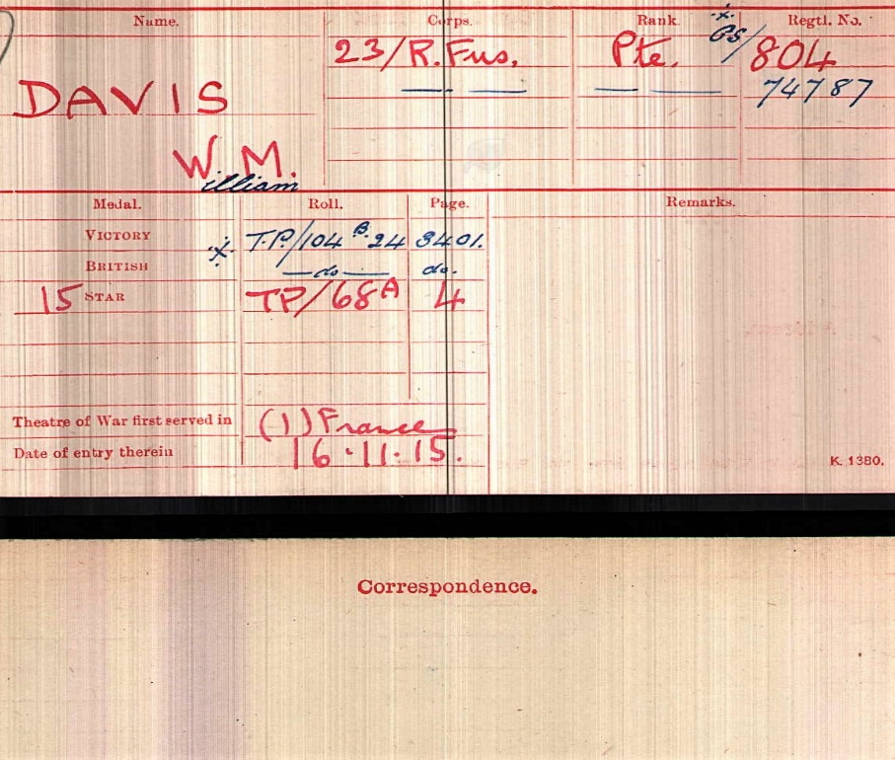

23rd (1st Sportsmans) Battalion Royal Fusiliers London Regiment

This battalion was raised and formed at the Hotel Cecil in the Strand, London, on the 25th September 1914 by E. Cunliffe-Owen. In June 1915 they joined the 99th Brigade, 33rd Division at Clipstone Camp near Mansfield in Nottinghamshire. In August1915 they moved to Salisbury Plain for final training and firing practice. In November they received orders to prepare to proceed to France and the Divisional Artillery and Train were replaced by units raised for the 54th (East Anglian) Division. By the 21st November the 33rd Division had concentrated near Morbeque. On the 25th November 1915 the Battalion transferred to the 2nd Division as part of an exchange to strengthen the inexperienced 33rd Division. They took part in the Winter Operation 1914-1915 and in 1915 saw action at the Battle of Festubert and the Battle of Loos. In 1916 they took part in the Battle of the Somme, including the Battle of Delville Wood and the Operations on the Ancre. In 1917 they were in action during the German Retreat to the Hindenberg Line, the Battle of Arras and the Battle of Cambrai. In 1918 they fought on the Somme, in the Battles of the Hindenberg Line and the Battle of the Selle. The 2nd Division was selected to advance into Germany and formed part of the Occupation Force after the Armistice.

Both the 23rd and 24th (2nd Sportsmans) Battalions entered Germany and were presented with Colours at the end of the War, an unusual mark of distinction for Kitchener Battalions in recognition of their service.

