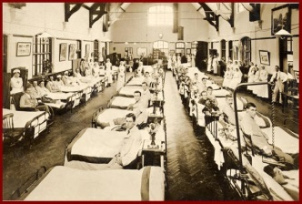
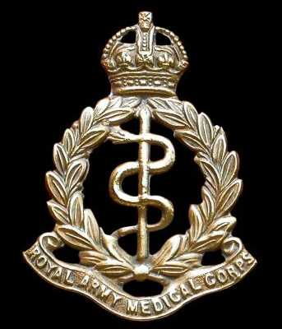
PRIVATE WILLIAM JOHN LYTTLE RAMC
1899-1917
William lived in Scotch Street, Downpatrick, and was an ironmonger by trade.
He enlisted in the Royal Army Medical Corps in October 1915, at the age of just 16. After training, he was posted to serve with the 49th Field Ambulance in France. Over a year went by, until on 23rd March 1917 he was wounded in the chest at the Battle of Arras. He was initially treated at a casualty clearing station, and then later transferred to a Canadian field hospital. Perhaps his wound was severe, or infection had set in, because he did not seem to be recovering. Finally, on 6th July he was conveyed on a hospital ship to Naunton Park Auxiliary Hospital in Cheltenham, where he died a week later, His body was then transported home for burial in Down Cathedral cemetery.

The Down Recorder states that William received full military honours at his funeral, with a firing party of RIR cadets. A piper played alternately Lord Lovat’s Lament and Oft in the Stilly Night. William was laid to rest in the Cathedral cemetery, after which three volleys were fired and the Last Post sounded. I think it is significant to add that it looks as though his mother never recovered from William’s death, as she herself died about 18 months later. She is also buried in the grave, as well as his father and sister. I discovered his untended grave by chance, as the RAMC emblem on the headstone attracted my attention. I have sown poppies on it by way of remembrance:

I’m sowing seeds on William’s grave,
He died so long ago,
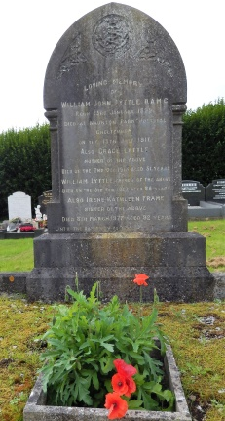
Having volunteered for France,
To face the German foe…
…He left his fond Downpatrick home,
And headed off to war—
Not with a fighting regiment,
But the Army Medical Corps.
He did his duty fearlessly
Behind the line of battle,
A year of blood and bandages,
Where men were felled like cattle.
One day in March a shrapnel shard,
Bit deep into his breast;
His first stop was a clearing station,
Where it could be dressed…
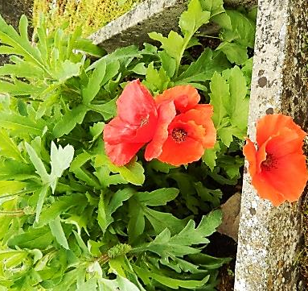
Thence to a hospital in France,
For gentle nursing care—
But the ugly wound refused to heal,
And hope turned to despair…
…So back to Britain once again,
They brought him in July:
In Cheltenham, in hospital,
Young William Lyttle died.
That’s why I’ve sprinkled poppy seeds—
To show he’s not forgotten—
Their blood-red blooms upon his grave
Remember all the Fallen.

Helen Long

The work of the Field Ambulances
Thanks to the war diary of 56 Field Ambulance RAMC we have an insight into the tasks undertaken by the men of the Ambulance. On 12 January 1916, when at Daours, the men were organised into the following parties:
8 wards, in two blocks of 4 each with a Sergeant Wardmaster and Corporal Assistant Wardmaster for each block.
33 men acting as nursing orderlies or general duty orderlies, including 7 men on night shift, in the wards.
5 men on pack store duties.
6 on rifle and kit cleaning.
3 men on hospital fatigues.
3 men on patients bath house duties.
6 men on RAMC men’s cookhouse and 3 on mens dining hall.
5 on patient’s cookhouse, 4 on canteen, 3 on patients dining room.
3 on billet cleaning.
4 in the dispensary.
6 in the wash house.
7 on sanitary squad.
4 at bathing establishment.
9 in drying room.
4 in quartermaster’s stores.
2 white washers.
1 in the ablution room.
1 fumigator.
1 in the cleaning yard.
2 bootmakers.
1 horsed ambulance driver.
1 tailor.
1 barber.
2 men at the ASC Refilling Point.
3 water cart orderlies.
5 loaders.
1 sick officer’s cook and 1 orderly, same.
5 permanent police squad.
2 in sergeant’s mess.
8 in officer’s mess.
11 men not detailed

