G898 Rifleman Frederick Heading
1st Garrison Battalion Royal Irish Rifles.

Frederick Heading was born on the 31st July 1895 in Belfast, Antrim, to Kate O’Sullivan, aged 30 and Samuel Heading, aged 48. He was one of nine children. He was at home for both the 1901 and 1911 census. He joined the military for the duration of the war in 1915 and his father Samuel died at the age of 70 on the 1st April 1917 while he was serving in India.
He initially attested for the Royal Irish Fusiliers and was posted to Buncrana, Donegal on the 11th November 1915. However he was transferred to 1st Garrison Battalion Royal Irish Rifles on 21st Jan 1916. He embarked on 20/6/16 at Devonport and disembarked at Bombay, India on the 13th March 1916 spending the rest of the war in the vicinity of Cawnpore. He spent a stretch of his later service in hospital in Cawnpore from early February 1919. He was recommended for evacuation back to the UK. A medical B1 type discharge followed to close his military reserve status.

After a mixed period of employment Freddy decided to emigrate to the USA and left on the 6th Aug 1922 aboard the SS Cedric from Liverpool. He settled in the Bronx and made his naturalisation declaration on the 13th April 1925. He married Selina Nicholl in Toronto, Canada on the 5th August 1925. Selina had arrived in Quebec in June 1924. They had 3 children Frederick born 1927, George born 1937 and Hilda born 1938 all in Bronx, New York. Frederick died on 1st July 1967 and Selina died about 1971.

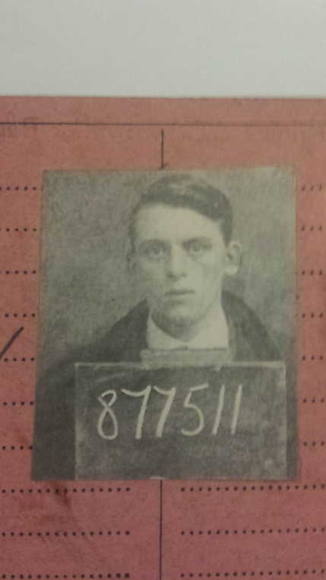
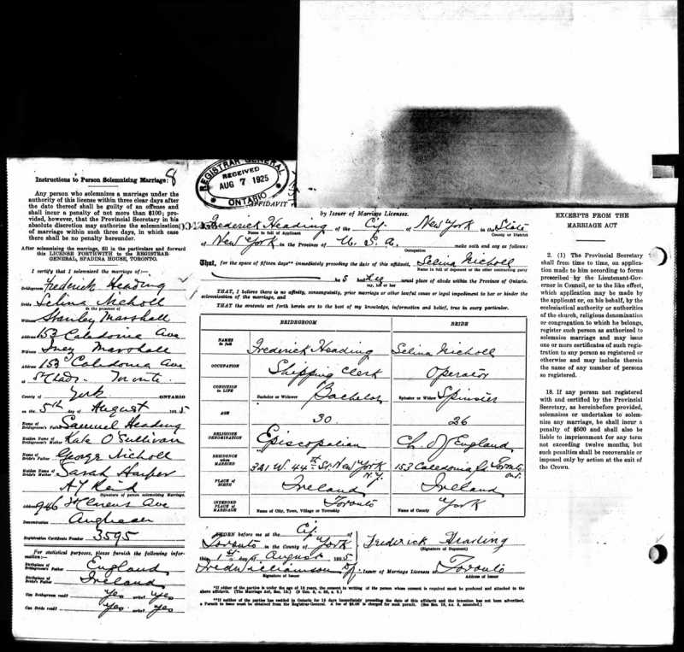

G898 Rifleman Frederick Heading
1st Garrison Battalion, Royal Irish Rifles.
Frederick Heading was born on the 31st July 1895 in Belfast. His parents were Samuel Heading and Kate Sullivan who lived at Kilronan Street in Belfast. He had 5 sisters and 3 brothers.
Military Service in WW1
There was no conscription in Ireland so all who enlisted were volunteers.
Frederick volunteered on the 11th November 1915 and signed on for the duration of the War.
He was initially enlisted into the Royal Irish Fusiliers 3rd Battalion and posted on the 11th November to Buncrana training depot by the shores of Lough Swilly, County Donegal, being allocated service number 3/22841
On enlistment he was recorded as 5 ft 5 and 3/4 inches tall and weighed 106 lbs. His trade was a Pumicer and he had slight medical defects to his left foot and an old injury scar to his right wrist. As a result he was posted to a Garrison Battalion which saw service in India so he did not serve in a fully active war zone during World War One.
He was transferred on the 27th January 1916 to the Royal Irish Rifles, D Company, 1st Garrison Battalion and allocated service number G/898.
He embarked at Devonport on the 20th February 1916 and disembarked at Bombay on the 15th March 1916 . He served mainly in Cawnpore and seemed to be badly affected by the climate as he had increasing spells of hospital treatment for bronchitis and other debilitating illnesses in 1917 and 1918, culminating in a mention of smallpox on 12th April 1919. He was recommended to be invalided to the UK on the 22nd March 1919.
He embarked for UK at Bombay on the 3rd May 1919 and taken on home strength on the 7th May 1919 probably to East Leeds War Hospital.
He was discharged from East Leeds War Hospital on the 17th June 1919.
He returned to Buncrana on the 17th June 1919 and was discharged with a medical category of B1 to Section Z Reserve on the 18th July 1919 having served 3 years and 247 days. He received a pension award of 5shillings and 6pence per week for 6 months based on his 20% disability assessment.
He had a few minor disciplinary events early in 1919 which were probably down to his being unwell and somewhat disillusioned with military service in what for him seemed to be a testing Indian climate.
He was awarded the British War Medal but was not entitled to the Victory Medal as he did not serve in the front line during the war. However in many ways he was fortunate that his physical condition on enlistment kept him clear of the active war theaters though the 3 years service in India took a heavy physical tone on him.
His elder brother Samuel George Heading also served with the Royal Irish Rifles but in the 1st Battalion on active service in France and likewise was discharged as unfit for war service after being wounded in September 1918.
Freddy later emigrated to the USA and married Selina Nicholl in Canada. They settled to life and family in New York and Frederick died on the 1st July 1967 in Bronx, New York.

