L/Cpl Samuel George Heading

Samuel George Heading was the son of Samuel Heading and Kate O’Sullivan. He was born in Manchester on the 15th November 1886. He was resident aged 4 in Glasgow during the 1891 census and in Belfast during the 1901 and 1911 census. He enlisted on the 19th September 1914 in the 1st Btn. Royal Irish Rifles and served in France during World War 1 in the rank of Lance Corporal. He married Mary Ann McMurray on the 15/12/1916 at St. John’s Church of Ireland, Laganbank, Belfast. They had 2 children Samuel and George. Mary died on 30/11/1926 from Nepritis (kidney infection). Samuel was awarded a Silver Badge (Number B3085) having been discharged as wounded on the 19th September 1918.

Samuel whose home was at Nile Street, Belfast , was later employed as a ship’s cook having been disabled prior to his discharge from the Army near the end of the war. On the 16th January1936 serving onboard the Belfast Steamer Lurigethan as ship’s cook, he met with an unfortunate accident when he apparently slipped near the gangway and fell into Canada Dock, Liverpool late on the Wednesday night. He was accidently drowned despite gallant attempts to keep him afloat by another member of the crew.

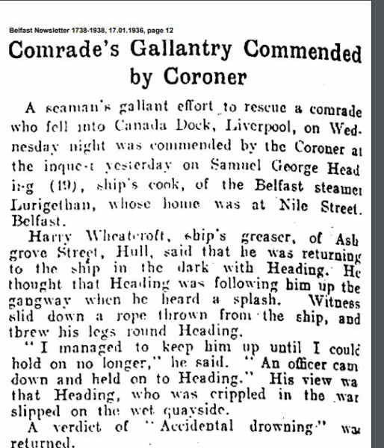
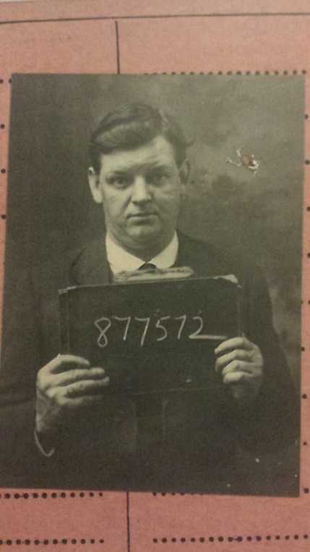

British Army WW1 Medal Rolls Index Cards 1914-1920
Heading Samuel George, Private. 4/7281 Royal Irish Rifles
Medals Victory, British War, 15 Star and SWB LIST B/929
Theatre of War France. Discharged.

1st Btn, Royal Irish Rifles, 107th Brigade, 36th Division

On 3 September 1914, just short of a month after Britain had declared war and after much discussion regarding what amounted to a political ‘truce’ with regard to domestic matters, Sir Edward Carson (one of the great political leaders opposing Home Rule for Ireland) made an appeal at the meeting of the Ulster Unionist Council in Belfast, urging the men of the Ulster Volunteer Force to come forward for service in the defence of the British Empire. Despite the fact that many Ulstermen had made their own decisions and had already enlisted, an entire formation known as the Ulster Division was soon raised – and all of its infantry units were based on existing units of the UVF. Thirteen battalions were raised for the three Irish regiments based in Ulster: the Royal Inniskilling Fusiliers, the Royal Irish Fusiliers and the Royal Irish Rifles.
1914
August: formed in Ireland as the Ulster Division, with Brigades numbered 1,2 and 3. On 28 August 1914, the Division and its Brigades adopted the titles shown on this page.
1915
July: the Division moved to Seaford on the Sussex coast of England. Lord Kitchener inspected the Division there on 27 July 1915, and later remarked to Carson “your Division of Ulstermen is the finest I have yet seen”. Another inspection took place, by King George V, on 30 September. On 3-6 October: the Division moved to France, although the artillery remained in England until November. The Ulster Division initially concentrated in the area around Flesselles, some ten miles north of Arras. Gradually, men were sent in groups for familiarisation with trench warfare conditions, and were attached to the regular army 4th Division for the purpose in the (at this time) quiet are north of the River Ancre near Albert. On 21 October the Division was moved away from the fighting area towards Abbeville, where it spent most of the winter of 1915-16 continuing training. One of the Brigades was attached to 4th Division for several weeks at this time and the artillery finally rejoined.
1916
The whole Division finally took over a complete section of the front line on 7 February, between the River Ancre and the Mailly-Maillet to Serre road. Division HQ was at Acheux. In the first week of March, the Division extended its front, the 109th Brigade taking over the sector south of the Ancre, known by the name of Thiepval Wood. The Division remained in the Wesrern Friont in France and Flanders throughout the rest of the war and took part in the following engagements. The Battle of Albert* in which the Division attacked at the Schwaben Redoubt near Thiepval overwhich the Division fought on 1st July 1916. The Division was relieved on 2 July, having suffered 5104 casualties of who approximately 2069 died.
1917
The Battle of Messines, in which the Division captured Wytschaete
The Battle of Langemarck.
The Cambrai Operations, including the capture of Bourlon Wood
1918
The Division was substantially reorganised in February 1918.
The Battle of St Quentin
The Actions at the Somme Crossings
The Battle of Rosieres
The Battle of Messines
The Battle of Bailleul
The First Battle of Kemmel Ridge
The Battle of Ypres
The Battle of Courtrai
The action of Ooteghem
On 11 November the Division was at Mouscron, north east of Tourcoing. It remained there throughout the period of demobilisation. It ceased to exist on 29 June 1919.
The Great War cost 36th (Ulster) Division 32186 men killed, wounded or missing.

1st Battalion
August 1914 : in Aden. Returned to UK and landed at Liverpool on 22 October 1914.
Moved to Hursley Park and came under command of 25th Brigade in 8th Division.
6 November 1914 : landed at Le Havre.
3 February 1918 : transferred to 107th Brigade in 36th (Ulster) Division.

