Harry Peden Family Summary

Harry (Henry) Peden was born on the 7th February 1886. His Father was Thomas Nathaniel Peden and his Mother was Elizabeth Peden nee Smith. He was at home on the 1901 Census as a scholar aged 15. He had left home prior to the 1911 census. Home Address was Mosside, Hollywood, Co. Down, Northern Ireland. 13425 Harry Peden had enlisted as a Private in the Royal Marines, Plymouth Division, on the 20/07/1905. He served onboard a number of naval ships and completed 8 years service, being permitted to retire from the Cambrian whilst on posting in Australia during August 1912. He was soon back in active service when war broke out in 1914 and he joined the 2nd Btn, Australian Infantry Force. (447 Pte Harry Peden). His Active Service Record shows he was wounded on his right forearm on the 02/05/1915 and admitted to hospital in Cairo. He rejoined his unit in Gallipoli on 22/06/2015 and was also promoted to Lance Sergeant. On the 14th August he was reported missing at Lone Pine in Anzac Cove. On the 24th August 2015 the status was changed to Killed in Action on Gallipoli Peninsula and he is noted as believed to be buried in the Lone Pine Cemetery (Actual grave unknown). Reference by 454 Private Quinlan, 2nd A.I.F. Gesira Hospital, Cairo.
447 Lance Sergeant Harry Peden was Killed in Action between 6th and 9th August 1915.
He fell during the charge on Lone Pine on the 6th August. Peden was a very popular man and nearly everyone hunted for the body which informant believes was found although not actually seen by him and Peden was buried in the Sap to the rear of the trenches. His next of kin was still recorded as his father Thomas Peden of Mosside, Holywood, County Down, Northern Ireland and was duly informed.

Royal Marines Service
Enlisted 20/07/1905, Plymouth Division 1/1/1906
Hibernia 1/1/1907 to 4/1/1909
Plymouth Division 5/1/1909
Hermes 28/02/1909 to 12/04/1911
Vindictive 13/04/1911 to 06/05/1911
Plymouth Division 07/05/1911 to 12/06/1911
Carnarvon 12/06/1911 to 26/07/1911
Plymouth Division 27/07/1911 to 07/08/1911
Cambrian 08/08/1911 to Release
and discharge in Australia on 08/08/1912.

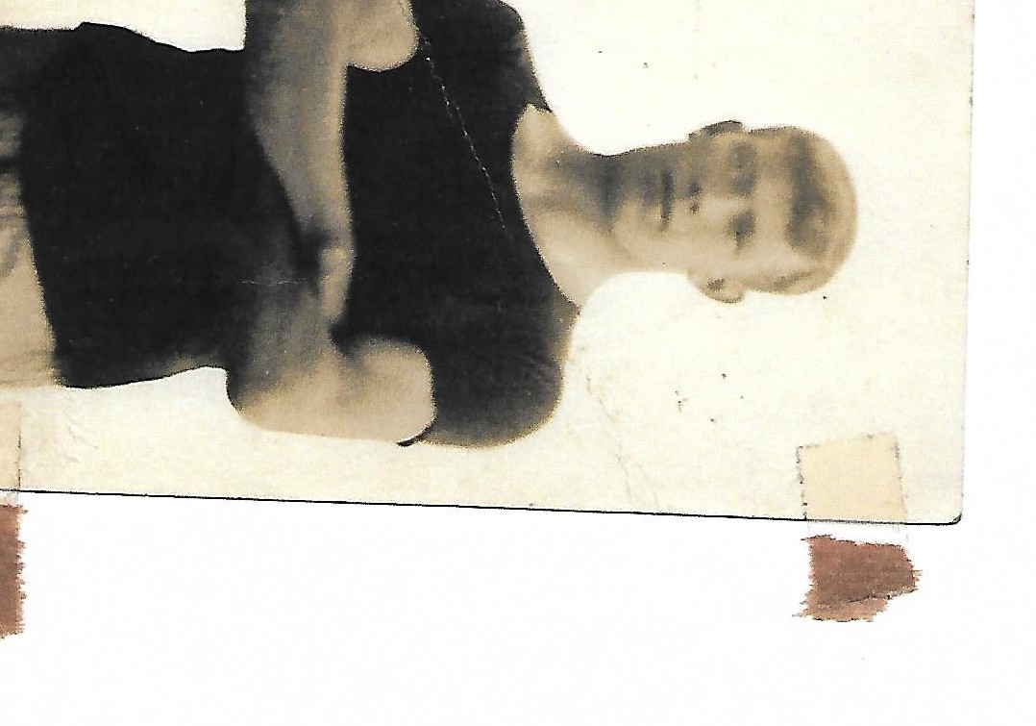
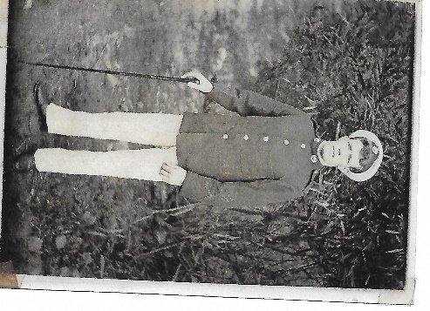

2nd Battalion, Australian Imperial Force

The 2nd Battalion was an infantry battalion of the Australian Army. It was initially raised for service during the First World War as part the Australian Imperial Force and saw action at Gallipoli before being sent to the Western Front in mid-1916, where it spent the next two-and-a-half years taking part in the fighting in the trenches of France and Belgium. Following the conclusion of hostilities, the battalion was disbanded in early 1919 as part of the demobilisation process.

The 2nd Battalion was raised at Randwick, New South Wales, in August 1914 as part of the Australian Imperial Force (AIF), which was formed from volunteers for overseas service shortly after the outbreak of the First World War. Drawing the majority of its personnel from the Maitland, Newcastle and Hunter Valley regions of the state of New South Wales, the battalion formed part of the 1st Brigade and, along with the 1st, 3rd and 4th Battalions, it was one of the first infantry units raised by Australia following its entry into the war. Upon formation, the battalion was established with a complement of over 1,000 men organised into a headquarters, a machine-gun section of two heavy Maxim medium machine-guns, and eight rifle companies, each consisting of three officers and 117 other ranks. The battalion's first commanding officer was Lieutenant Colonel George Braund, a citizen soldier and Member of Parliament in the New South Wales Legislative Assembly, who held the seat of Armidale. The physical standards under which the first contingent of the AIF was recruited were very strict, nevertheless by the end of August over 20,000 men had been recruited into one infantry division—the 1st Division—and one light horse brigade, the 1st Light Horse Brigade. Following a brief period of training in Australia, the force set sail for the Middle East, assembling off Albany, Western Australia, in early November 1914 before leaving Australian waters, with the 2nd Battalion embarked upon the HMAT Suffolk.

Initially it had been planned that the Australians would be sent to the United Kingdom, where they would undertake further training prior to being sent to the Western Front in France and Belgium. However, the Ottoman Empire's entry into the war on Germany's side on 29 October meant that the strategically vital Suez Canal was threatened, and as a result of this and overcrowding in training grounds in the United Kingdom, upon the convoy reaching the Suez at the end of November, plans for the use of the Australian force were changed and they were disembarked in Egypt instead. The 2nd Battalion arrived in Egypt on 2 December. The following month, it undertook further training along with the rest of the 1st Division. The battalion was also re-organised into four companies, as the Australian Army converted to the new battalion structure that had been developed by the British Army. Although the battalion's authorised strength remained the same, the eight companies were merged into four, each consisting of six officers and 221 other ranks In February 1915, Ottoman Empire forces attacked the Suez Canal, and although some units of the 1st Division were put into the line, the 2nd Battalion was not required, and in the end the attack was turned back mainly by Indian units. Later, in an effort to open shipping lanes to the Russians and also knock the Turks out of the war, the British high command decided to land a force on the Gallipoli peninsula near the Dardanelles using mainly British, French and Indian troops along with the Australians and New Zealanders.

Gallipoli Lone Pine Attack
During the Landing at Anzac Cove on 25 April 1915, the 2nd Battalion, under Braund's command, came ashore in the second and third waves, landing a total of 31 officers and 937 other ranks. Upon landing, the 2nd Battalion dispatched two companies, 'A' and 'D' to assist the 3rd Brigade who were pushing inland towards a high feature known as "Baby 700", which overlooked the beachhead. One of the 2nd Battalion's platoons, under Lieutenant Leslie Morshead, advanced further than any other Australian unit, making it to the slopes of Baby 700, before a determined counter-attack by Ottoman forces drove them back in the afternoon. Meanwhile, the battalion's other two companies, 'B' and 'C', had been held back in reserve. In the early afternoon, Braund led them up the steep terrain under fire to the vital junction between two positions known as "Walker's Ridge" and "Russell's Top". The battalion proceeded to hold this position until reinforcements arrived from the Wellington Battalion two days later, at which time the 2nd Battalion undertook a bayonet charge which cleared the crest of Russell's Top. A determined enemy counter-attack forced them back to the junction where they remained until 28 April when they were ordered into reserve on the beach.
In early August, in order to create a diversion to draw Ottoman reserves away from a major attack at Hill 971, which had been conceived as part of an attempt to break the stalemate that had developed around the beachhead, the 1st Brigade conducted an attack at Lone Pine. The 2nd Battalion was chosen to take part in the initial assault. After gaining possession of the main enemy line, the Australians were subjected to a series of determined counter-attacks which would last the next three days, which, although successfully repulsed, proved very costly for the Australians. The 2nd Battalion suffered considerably. Having started the action with 22 officers and 560 other ranks, they lost 21 officers and 409 other ranks killed or wounded. Among those killed was its commanding officer, Scobie, who was shot dead while attempting to repulse a counter-attack on 7 August. In Scobie's place, the battalion second-in-command, Major Arthur Stevens, who had been a second lieutenant less than 12 months before, took over as temporary commander.
Elsewhere, the main offensive which had been launched at Hill 971 and Sari Bair, and the fresh landings that had taken place at Suvla Bay, also faltered. Ultimately, the August Offensive, of which the fighting at Lone Pine had been a part, failed to deliver the Sari Bair heights to the British Empire forces and their allies, nor did it break the deadlock. Following this, stalemate returned to the peninsula during September and October, and although small skirmishes continued, the Australians were mainly involved in defensive actions. As a result of the setback, many of the strategic goals that had been the basis of the campaign were abandoned and as a bitter winter set-in in November, there was much debate among the British high command about the utility of continuing the campaign. In the intervening months, some personnel had been shifted away from Gallipoli as other the situation in other theatres became more relevant, and in late November, Lord Kitchener toured the peninsula. Finally, on 8 December, the order to begin the evacuation was given. The evacuation, which has been described as "more brilliantly conducted ... than any other phase of the campaign", took place in stages, and with the maintenance of secrecy a key consideration, a series of "ruses" were used to conceal the withdrawal. Each unit left in drafts, maintaining a presence along the line until the very end. Finally, just before dawn on 20 December, the evacuation was complete. A small element from the 2nd Battalion was among the last Australian troops to leave, with a group of 64 men remaining in possession of the "Black Hand" position until 2:50 am on the final morning.

