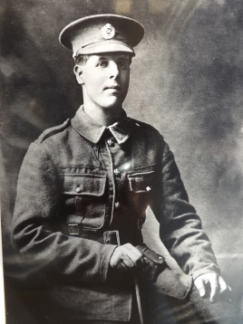

SAPPER JOHN MALONE
Helen Long’s maternal Great-uncle

Sapper John Malone was the younger brother of Helen’s grandfather Samuel Walmsley Malone. A Downpatrick carpenter by trade, it was fitting that John enlisted in the Royal Engineers (36 Ulster Division), at Belfast City Hall on 4th January 1915.
Following initial training, he served in northern France, and was very involved in preparations for the Somme offensive. However, on 23rd May 1916, he was mortally wounded in the chest by a bullet from a machine gun, ‘while working on a new MG Emplacement, being one of those chosen for their skill and bearing for a working party’. Mercifully he died within minutes. His obituary states that ‘John has always been one of the steadiest and most dependable soldiers of his company’; and that he ‘died as a soldier of Christ and of his country, well liked by his officer and comrades’. Among his papers was his New Testament which looked well worn, as if it had been constantly used. He was known to have had a girlfriend back home in Downpatrick.

He rests at peace now, in Hamel Military Cemetery, near the village of Albert. Helen and her parents, Harry & Edith, had the privilege of visiting his grave in 1981; they found it an extremely moving experience. A field of wheat now grows in the place where John died.

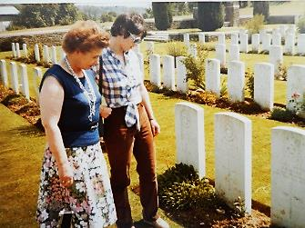
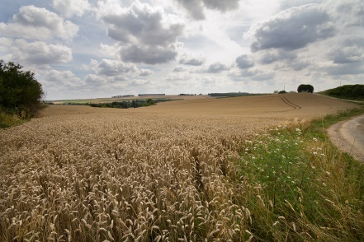

36 th (Ulster ) Division, Divisional Troops, Engineers

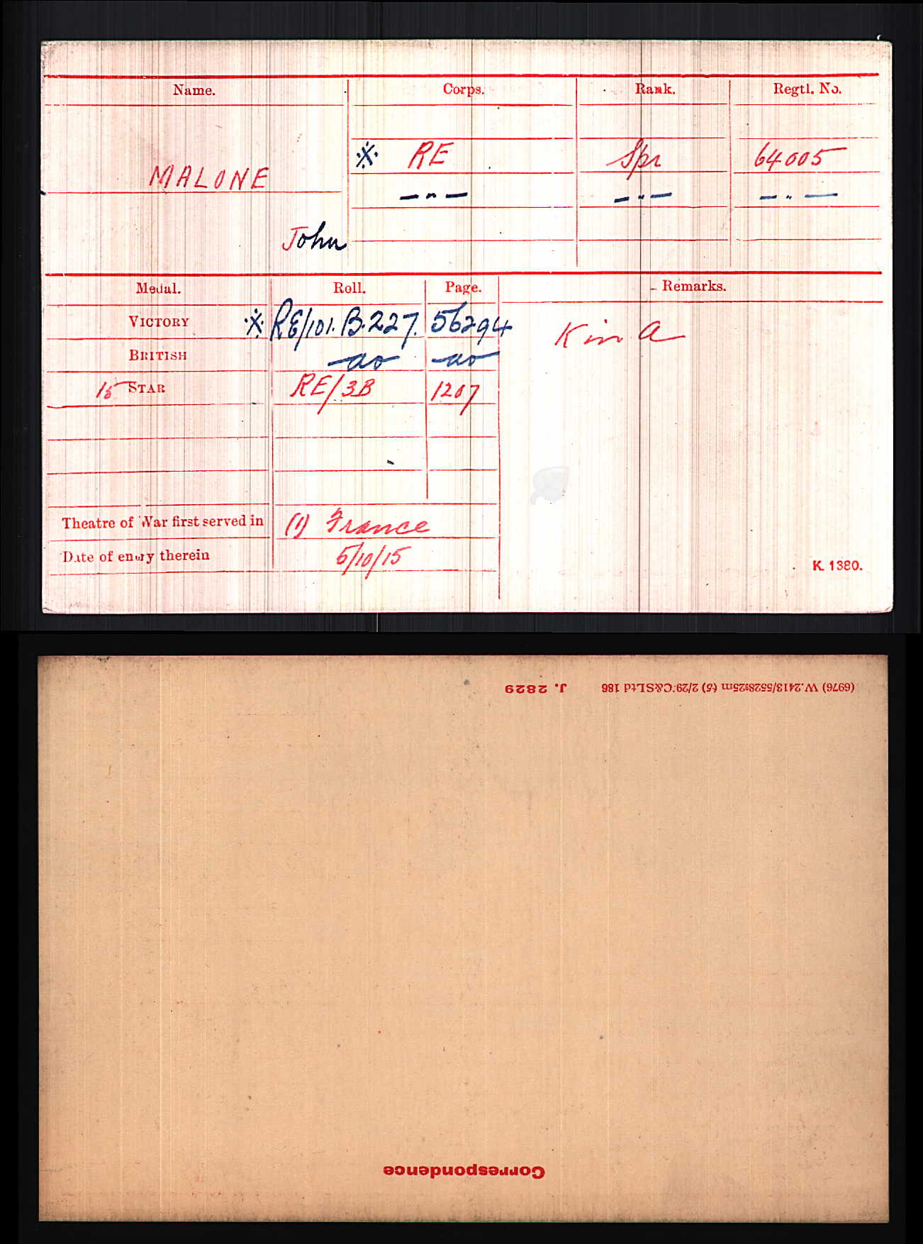
The divisional structure was organized to support 3 Infantry Brigades by divisional troops amongst which were Field Companies of Royal Engineers.

The reference 'attached' is slightly misleading. The three field companies, 121st, 122nd and 150th were the Ulster Division Engineers through-out the war. Like all other field companies they stayed with their Division for the duration, unlike infantry battalions which were 'attached' to a Division and would be moved or disbanded as seen fit.
They carried out all activities from light road repair, combat duties and general maintenance & construction of trench dugouts, but most trench work was done by infantrymen under the supervision of sappers, particularly by the 16th Battalion Royal Irish Rifles which was designated as a Pioneer Battalion for the Division and worked closely with the Sappers.
With the Ulster Division the format was generally, but not always, 121st served 107th Infantry Brigade, 122nd served 108th Infantry Brigade and 150th the 109th Infantry Brigade.
On 1st July 1916 a section of 150th went over the top with the 11th Inniskillings in the first waves, they lost their first officer Lt Peakock, who is buried in Connaught Cemetery, as they left the wood.
The 150th were generally used as the Division combat engineers, with one of the officers writing of the Somme 'we consolidated the trench before it was taken'.
On the 1st July, the 121st were in Thiepval Wood assisting the infantry move ammunition forward and later providing water to the wounded as they came back in. They also had to help clear the bodies from the trenches and keep the routes through the wood clear.
One of the main battles the 121st were involved in was the crossing of the river Lys in 1918, under heavy fire. They built pontoons for the infantry to cross on so were exposed for a long period of time.
Although not officially recorded they carried out training at Henley on Thames and there is a series of photographs taken of them on a pontoon bridge adjacent to the existing road bridge at Henley.
The 5/6 original Officers were English and in August 1917 had a bad run, losing three of them. They served in all of the major engagements of the Division in either active or support roles.
One of their finer actions was in March 1918 and I think your SMLE may have seen some serious action. The three field companies together with a machine gun section made a stand during the retreat allowing the Division to adjust its position. The diary gives an interesting report on these times and the disappearance of a section of men sent off to sort a bridge. This report refers to the general control of Engineering work on the Western Front in the 36th Ulster Division.

