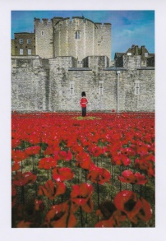
HERBERT ERNEST CAMPBELL

Uncle of Ethel Campbell’s late husband, Stewart

Young Rifleman Herbert Campbell was yet another
local casualty of the War. But tragedy had already
entered his life long before hostilities ever began.

Herbert was the eldest of three children born to his
parents in Belfast. His father served in the army, and it was during the time he was stationed in England that his mother died in childbirth, leaving Herbert (4), Willie (2), and Minnie (the newborn baby). The two younger children were taken by uncles and aunts to be reared, but Herbert went to live with his paternal grandmother, in Battenberg Street off the Shankill Road. His grandmother was in the Salvation Army, but Herbie went to Saint Matthew’s Church of Ireland and became a keen member of the Church Lads’ Brigade.

Herbert would have been only 16 when war broke out in 1914, as indeed would most of his fellow Church Lads. Yet amazingly he, and almost all 55 of the seniors of the Lads’ Brigade, lied about their ages and joined up in 1914 with the 36th Ulster Division. Herbert’s Service Number was 1567 and he enlisted in the 10th Battalion of the Royal Irish Rifles. Unsurprisingly, in the summer of 1916, they were heavily involved in the allied attack on 1st July, the infamous Battle of the Somme. What a terrible tragedy that every one of those Church Lads, was killed that day save one (Sam Maguire). Valiant young Herbert Campbell had left his home in far-away Battenberg Street, only to be cut down by a machine-gun on the killing fields of the Somme. He was only 18 years old.

A war correspondent who wrote about the battle recalled that on the day they went over the top, he was stopped by a young soldier who asked him to post a letter to his granny, telling him he lived at Battenberg Street, Shankill Road. This could only have been Herbert, thinking of his beloved grandmother on the brink of battle. What a pity that letter has not survived. As well as the letter, of course, she would have received the dreaded telegram bearing the fateful news: Killed in Action. Herbert’s is one of the thousands of names recorded on the Thiepval Monument, where the Last Post is still played every evening through the year.

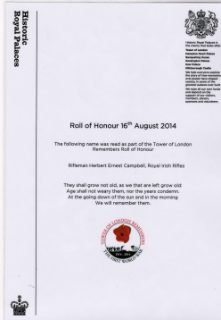
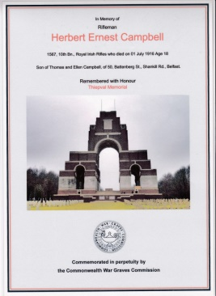
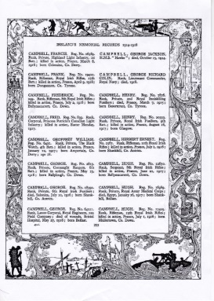

10th Btn, Royal Irish Rifles, 107th Brigade, 36th Division
On 3 September 1914, just short of a month after Britain had declared war and after much discussion regarding what amounted to a political ‘truce’ with regard to domestic matters, Sir Edward Carson (one of the great political leaders opposing Home Rule for Ireland) made an appeal at the meeting of the Ulster Unionist Council in Belfast, urging the men of the Ulster Volunteer Force to come forward for service in the defence of the British Empire. Despite the fact that many Ulstermen had made their own decisions and had already enlisted, an entire formation known as the Ulster Division was soon raised – and all of its infantry units were based on existing units of the UVF. Thirteen battalions were raised for the three Irish regiments based in Ulster: the Royal Inniskilling Fusiliers, the Royal Irish Fusiliers and the Royal Irish Rifles.
1914
August: formed in Ireland as the Ulster Division, with Brigades numbered 1,2 and 3. On 28 August 1914, the Division and its Brigades adopted the titles shown on this page.
1915
July: the Division moved to Seaford on the Sussex coast of England. Lord Kitchener inspected the Division there on 27 July 1915, and later remarked to Carson “your Division of Ulstermen is the finest I have yet seen”. Another inspection took place, by King George V, on 30 September. On 3-6 October: the Division moved to France, although the artillery remained in England until November. The Ulster Division initially concentrated in the area around Flesselles, some ten miles north of Arras. Gradually, men were sent in groups for familiarisation with trench warfare conditions, and were attached to the regular army 4th Division for the purpose in the (at this time) quiet are north of the River Ancre near Albert. On 21 October the Division was moved away from the fighting area towards Abbeville, where it spent most of the winter of 1915-16 continuing training. One of the Brigades was attached to 4th Division for several weeks at this time and the artillery finally rejoined.
1916
The whole Division finally took over a complete section of the front line on 7 February, between the River Ancre and the Mailly-Maillet to Serre road. Division HQ was at Acheux. In the first week of March, the Division extended its front, the 109th Brigade taking over the sector south of the Ancre, known by the name of Thiepval Wood. The Division remained in the Wesrern Friont in France and Flanders throughout the rest of the war and took part in the following engagements. The Battle of Albert* in which the Division attacked at the Schwaben Redoubt near Thiepval overwhich the Division fought on 1st July 1916. The Division was relieved on 2 July, having suffered 5104 casualties of who approximately 2069 died.
1917
The Battle of Messines, in which the Division captured Wytschaete
The Battle of Langemarck.
The Cambrai Operations, including the capture of Bourlon Wood
1918
The Division was substantially reorganised in February 1918.
The Battle of St Quentin
The Actions at the Somme Crossings
The Battle of Rosieres
The Battle of Messines
The Battle of Bailleul
The First Battle of Kemmel Ridge
The Battle of Ypres
The Battle of Courtrai
The action of Ooteghem
On 11 November the Division was at Mouscron, north east of Tourcoing. It remained there throughout the period of demobilisation. It ceased to exist on 29 June 1919. The Great War cost 36th (Ulster) Division 32186 men killed, wounded or missing.

