1137 Sapper Edward W Eachus D.C.M

Edward W Eachus was born in 1880 and his parents were Edward Eachus and Elizabeth Jones. He is called Edward and Edmund in the various Census Returns and was employed as an Engineer’s Pattern Maker following in his father’s footsteps. He is noted as being married to Therese in the 1911 Census. He was badly injured in Gallipoli and probably returned eventually to his former employment. It also seems that he passed away in 1945.

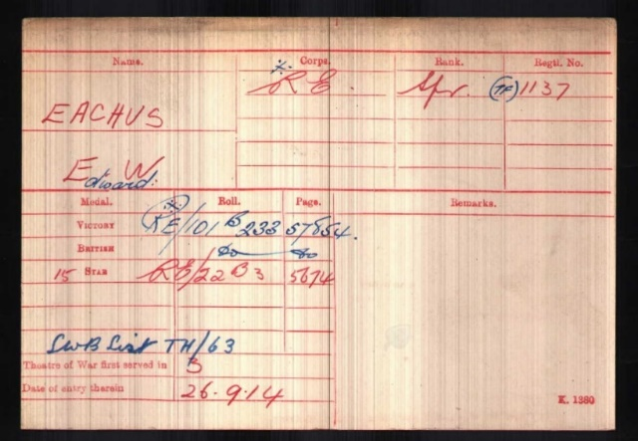
1137 Sapper Edward W. Eachus enlisted in the Royal Engineers and was posted to 2nd East Lancs Field Company, later renamed 428th Field Company, attached to the 42nd ( East Lancashire) Division.
Edward served in the Mediterranean Expeditionary Force and saw action in Gallipoli. He qualified for campaign medals in the 1915 Star, British War and Victory Medals. He was awarded the Distinguished Conduct Medal.
On the 14/07/1915 he was noted as wounded on the casualty list entitling him to wear a Silver War Wound Stripe from 6th July 1916. Edward received an honorary plaque from Salford Borough Council in acknowledgement.

Edward was awarded Distinguished Conduct Medal for conspicuous gallantry and devotion to duty. He organised a party of infantry and supervised the work of consolidation. He was subsequently severely wounded.
Gazette Date: 26/07/1917
Gazette Page: 7654

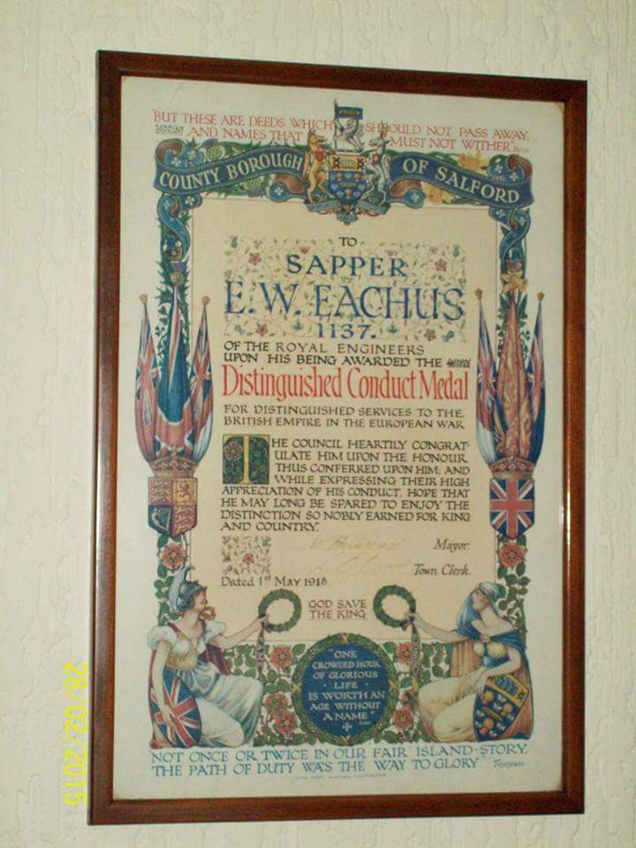

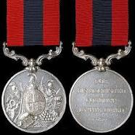

2nd East Lancashire Field Company RE, 127th Brigade, 42nd (East Lancashire) Division

42nd. Division was one of 14 peacetime Territorial Force Divisions formed in 1908. It was the first TF Division to move overseas and set sail for Alexandrea on 10 Sep 14, arriving commencing on 25 Sep 1914. Three Infantry Brigades and Divisional troops formed the structure of the Division. The Division concentrated around Cairo, where acclimatisation and further training commenced. The Manchester Brigade remained at Alexandria, sending one battalion to Khartoum and half a battalion to Cyprus, to garrison key military installations. Initially, Britain set out only to defend the Suez Canal from the Turkish troops that were massed in Palestine, and it was for this purpose that the East Lancashire Division was moved to the theatre. Detachments from the Division began to move to the Canal Zone in October 1914.The first clash in the Suez area occurred on 20 November 1914, when a patrol of the Bikanir Camel Corps met 200 Turk-controlled mounted Bedouin east of Kantara.
1915
By mid-January 1915 the Turks were ready to advance, having assembled a force of two Divisions with another in reserve, plus assorted camel and horse units. This was not a big force, considering the scale of their ambition was to wrest Egypt from British control and score a strategic success by seizing the canal. The force took the central route across the Sinai desert, taking ten days to reach the canal zone, intending to capture Ismailia and therefore the critical drinking water supplies. British aircraft tracked their progress; on 28 January 1915 observers identified a large column of troops on the centre route. British and French ships entered the canal, and opened fire while infantry manned defensive positions. Patrols clashed on 2 February, but a sandstorm halted any further action until next day. Various units of the East Lancashire Division were engaged in defending against the Turk attack on 3 February 1915.Once this first threat had subsided, they remained in the Canal Zone, until ordered to reinforce the beleaguered garrison on Gallipoli. The East Lancashire Division began to embark at Alexandria on 1 May 1915. The first transports left next day, and the last on 6 May. 14,224 men of the Division landed at Cape Helles. The Division was involved in three notable attempts to break out of the Helles bridgehead to capture the dominating heights around the village of Krithia. These attacks took place on 6-8 May (in which only the Lancashire Fusiliers Brigade of the Division took part), 4 June and 6-13 August. The last of these is known officially as the Battle of Krithia Vineyard, which gives some impression of the relatively small areas being so violently contested. It was undertaken not only to try to capture ground but to divert Turk attention from a large British landing further up the coast at Suvla Bay; an enterprise which failed and ultimately led to the decision to evacuate the hopeless position on Gallipoli. By mid-August 1915 the East Lancashire Division, through battle casualties and sickness, was down to little more than one third of its normal establishment. It received reinforcement in the shape of men of the Yeomanry, fighting dismounted. The Division, along with all other units in the Helles bridgehead, made a successful withdrawal from Gallipoli by 8 January 1916.

1916

After a short stay on Mudros while sufficient shipping was made available and the army administration got on top of the flood of units coming to Egypt from Gallipoli, the Division returned to Alexandria.

The Battle of Romani (4-5 August 1916)

Further work was undertaken on the Suez Canal defences throughout the spring and summer of 1916. In early August 1916, the Lancashire Fusiliers and Manchester Brigades made a very long march under blazing sun, towards Romani where a short engagement took place in which the Turkish units were pushed back with heavy loss. The Brigades (of the by now retitled 42nd (East Lancashire) Division) had to wade and struggle through loose sand, and the physical effort was extreme. Many men collapsed.
Romani was an important victory, because from there the British force pushed a railway and water line across the Sinai desert that would enable an assault with the intention of clearing Palestine. The East Lancs were involved as advance guards as the building moved forward as far as El Arish. However, a decision had been taken to restructure the force in Palestine, and in consequence the Division was ordered for the first time to the Western Front. All units embarked at Alexandria by the end of February 1917.
1917
On arrival and after being re-equipped for trench warfare in very different conditions to those the men had become accustomed to, the Division entered the line at Epehy, as part of III Corps in Fourth Army. They remained in this area, soon moving to Havrincourt where they remained until 8 July. These positions faced the formidable German Hindenburg Line in front of Cambrai. Through the rest of July and August, the Division carried out rest and training, in the area of Albert (on the old Somme battlefield of 1916).

