James Samuel Emerson

James was born on the 3rd August 1895 at Seven Oaks, Collon, Drogheda, Co. Louth, Ireland. He was the younger son of John and Ellen Emerson. His older brother was Mr W.A. Wallace Emerson, who was an Inland Revenue Officer, of Palace Row, Armagh. James was educated at Mountjoy School in Dublin.

Military Service: James enlisted on the 15th September as a Rifleman in the 3rd Btn. Royal Irish Rifles, Service No. 14430 and served on the Western Front. He was wounded in action at Hooge and spent 8 months in hospital. He served in the 9th Btn Royal Irish Rifles (West Belfast Volunteers) before receiving a commission. He returned to France during July 1916 and gazetted to the Inn (1/8/1917). At the time he was serving in the 9th (Tyrone) Battalion, Royal Inniskilling Fusiliers.
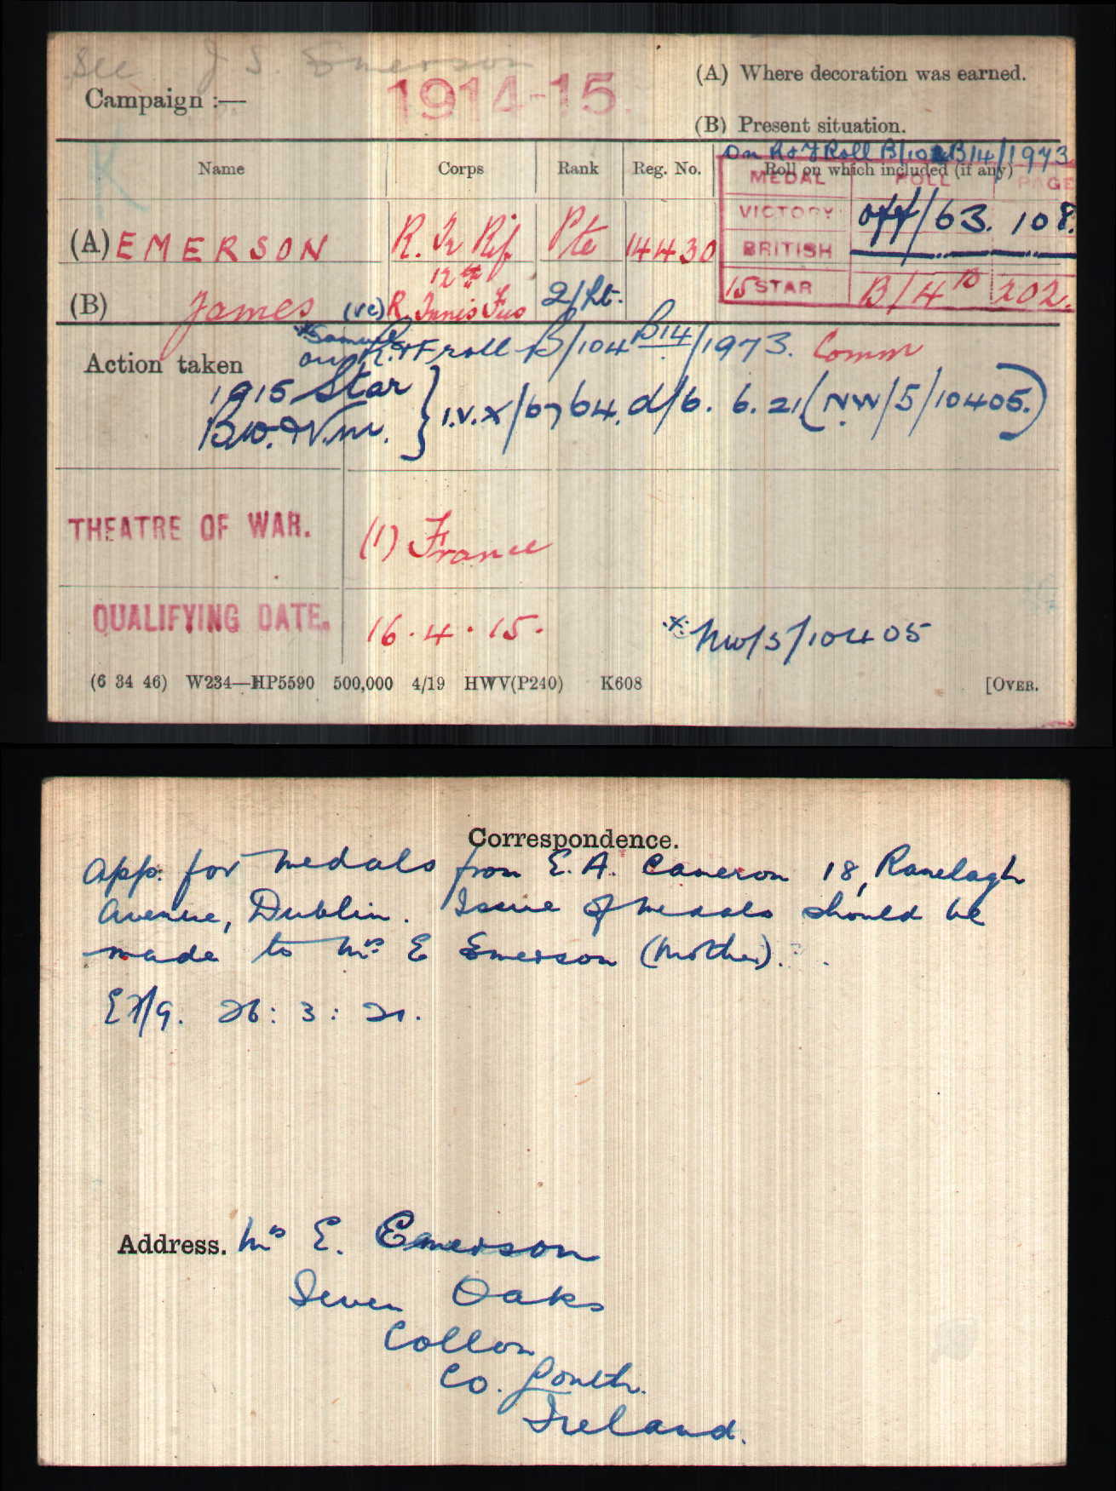
James was Killed in Action on the 6/12/1917 at La Vacquerie, Hindenburg Line, France. He was awarded the Victoria Cross and his citation in the London Gazette (13/2/1918) reads:
“For repeated acts of most conspicuous bravery. He led his company in an attack and cleared 400 yards of trench. Though wounded, when the enemy attacked in superior numbers he sprang out of the trench with 8 men and met the attack in the open, killing many and taking six prisoners. For 3 hours after this, all other officers having become casualties, he remained with his company, refusing to go to the dressing station, and repeatedly repelling bombing attacks. Later, when the enemy again attacked in superior numbers, he led his men to repel the attack and was mortally wounded. His heroism when worn out and exhausted from loss of blood, inspired his men to hold out, although almost surrounded, till reinforcements arrived and dislodged the enemy.”

James has no known grave and is Commemorated on the Cambrai Memorial to the Missing. His name also appears on the War Memorial in Collon, Drogheda.
Prior to his enlistment he had been an employee of the Bank of Ireland.
Location of Victoria Cross: His V.C. was presented to his mother Ellen in Drogheda, by Brigadier-General G. Hacket-Pain, C.B., on 3/4/18. It is now held by his nephew, Mr Lennox Emerson.

Earlier Army Service. Rank Acting Corporal.
Regimental Number 14430 2nd Btn Royal Irish Rifles
3rd Reserve Btn Royal Irish Rifles
9th Btn Royal Irish Rifles
3rd Reserve Btn Royal Irish Rifles.

James Samuel Emerson VC
Person
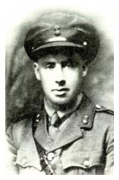
Second Lieutenant James Samuel Emerson VC
James Samuel Emerson was born on 3 August 1895 in the village of Collon, near Drogheda, in County Louth, Ireland. He enlisted into the 3rd Battalion The Royal Irish Rifles, a Reserve Battalion in Dublin, on 16 September 1914, and completed his training before sailing for France with the British Expeditionary Force on 16 April 1915. He served as a machine gunner and was promoted twice. As a Corporal he was wounded at Hooge on 29 September and evacuated to a hospital in the United Kingdom. When his convalescence was complete on 24 January 1916 he was posted to the Garrison Battalion, 3 RIR, in Portobello Barracks (now Cathal Brugha Barracks), Dublin and was there during the Easter Rising. He returned to 9 RIR in France on 28 June 1916 and fought at the Battle of the Somme. On 7 February 1917, he returned to Lichfield, England and began officer cadet training. On completion, he was posted on 1 August 1917 to the 9th Battalion The Royal Inniskilling Fusiliers as a (Temporary) Second Lieutenant.

