**14139 CQMS John(also known as Jack) Woods DCM**

Thank you for your interest in our family history. My grandfather and his two brothers fought in the First World War.  
My grandfather John Woods, known as Jack, fought with 11th Royal Inniskilling Fusiliers We think he joined up in 1914 when he was 18. He never talked about it, but we know he was a CQMS, was at the Somme and was awarded the DCM in June 1918.  
The three brothers were from Ballinamallard and were from a family of 13.

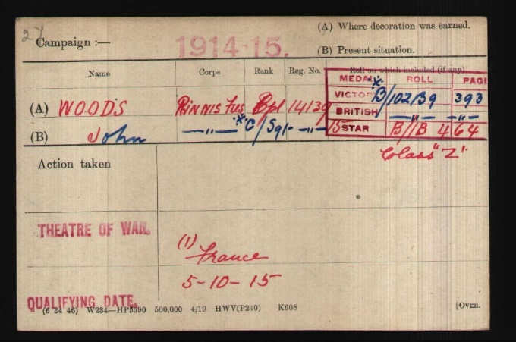**J. Woods**

**Male**

**CQMS**

**21 Oct 1918**

**UK Ballinamallard**

**Royal Inniskilling Fusiliers**

**14139.**

**Qualified for 1915 Star on**

**15th October 1915.**

**Awarded DCM in June 1918**

**Published in London Gazette**

**In October 1918.**

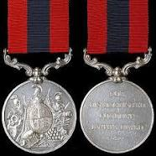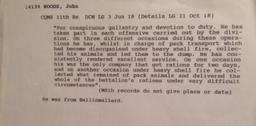

|  |  |
| --- | --- |
|  |  |

The **Distinguished Conduct Medal**, post-nominal letters **DCM**, was established in 1854 by [Queen Victoria](https://en.wikipedia.org/wiki/Queen_Victoria) as a decoration for gallantry in the field by [other ranks](https://en.wikipedia.org/wiki/Other_ranks_(UK)) of the [British Army](https://en.wikipedia.org/wiki/British_Army). It is the oldest British award for gallantry and was a second level military decoration, ranking below the [Victoria Cross](https://en.wikipedia.org/wiki/Victoria_Cross), until its discontinuation in 1993 when it was replaced by the [Conspicuous Gallantry Cross](https://en.wikipedia.org/wiki/Conspicuous_Gallantry_Cross). The medal was also awarded to non-commissioned military personnel of other [Commonwealth](https://en.wikipedia.org/wiki/Commonwealth_of_Nations) Dominions and Colonies.

The Distinguished Conduct Medal was instituted by Royal Warrant on 4 December 1854, during the [Crimean War](https://en.wikipedia.org/wiki/Crimean_War), as an award to Warrant Officers, Non-Commissioned Officers and men of the [British Army](https://en.wikipedia.org/wiki/British_Army) for "distinguished, gallant and good conduct in the field". For all ranks below commissioned officer, it was the second highest award for gallantry in action after the [Victoria Cross](https://en.wikipedia.org/wiki/Victoria_Cross), and the other ranks equivalent of the [Distinguished Service Order](https://en.wikipedia.org/wiki/Distinguished_Service_Order), which was awarded only to commissioned officers. Prior to its institution, there had been no official medal awarded by the British Crown in recognition of individual acts of gallantry in the Army. The Distinguished Conduct Medal was awarded with a gratuity, that varied in amount depending on rank, and given on the recipient's discharge from the Army. Since January 1918 recipients have been entitled to the [post-nominal letters](https://en.wikipedia.org/wiki/Post-nominal_letters) DCM. A [bar](https://en.wikipedia.org/wiki/Medal_bar) to the medal, introduced in 1881, could be awarded in recognition of each subsequent act of distinguished conduct for which the medal would have been awarded.

During the First World War, concern arose that the high number of medals being awarded would devalue the medal's prestige. The [Military Medal](https://en.wikipedia.org/wiki/Military_Medal) was therefore instituted on 25 March 1916 as an alternative and lower award, with the Distinguished Conduct Medal reserved for more exceptional acts of bravery. Around 25,000 Distinguished Conduct Medals were awarded during the First World War, with approximately 1,900 during the Second World War.

**11th (Service) Battalion (Donegal and Fermanagh)**  
Formed at Omagh in September 1914 from the Donegal and Fermanagh Volunteers. Came under orders of 3rd Brigade, Ulster Division and moved to Finner Camp.  
Record same as 9th Bn.  
21 January 1918 : disbanded in France, most officers and men being posted to 9th Bn.

**9th (Service) Battalion (County Tyrone)**  
Formed at Omagh in September 1914 from the Tyrone Volunteers (included two companies of Volunteers who had already joined the 5th and 6th Bns.). Came under orders of 3rd Brigade, Ulster Division and moved to Finner Camp.  
2 November 1914 : formation renamed 109th Brigade, 36th (Ulster) Division. Moved to Randalstown in January 1915 and on to Ballycastle in July 1915. Moved to England and went to Bordon in early September 1915.  
Landed in France in October 1915.

11th Btn, Royal Inniskilling Fusiliers, 109th Brigade, 36th Division

On 3 September 1914, just short of a month after Britain had declared war and after much discussion regarding what amounted to a political ‘truce’ with regard to domestic matters, Sir Edward Carson (one of the great political leaders opposing Home Rule for Ireland) made an appeal at the meeting of the Ulster Unionist Council in Belfast, urging the men of the Ulster Volunteer Force to come forward for service in the defence of the British Empire. Despite the fact that many Ulstermen had made their own decisions and had already enlisted, an entire formation known as the Ulster Division was soon raised – and all of its infantry units were based on existing units of the UVF. Thirteen battalions were raised for the three Irish regiments based in Ulster: the Royal Inniskilling Fusiliers, the Royal Irish Fusiliers and the Royal Irish Rifles.

***1914***  
August: formed in Ireland as the Ulster Division, with Brigades numbered 1,2 and 3. On 28 August 1914, the Division and its Brigades adopted the titles shown on this page.

***1915***  
July: the Division moved to Seaford on the Sussex coast of England. Lord Kitchener inspected the Division there on 27 July 1915, and later remarked to Carson “your Division of Ulstermen is the finest I have yet seen”. Another inspection took place, by King George V, on 30 September. On 3-6 October: the Division moved to France, although the artillery remained in England until November. The Ulster Division initially concentrated in the area around Flesselles, some ten miles north of Arras. Gradually, men were sent in groups for familiarisation with trench warfare conditions, and were attached to the regular army 4th Division for the purpose in the (at this time) quiet are north of the River Ancre near Albert. On 21 October the Division was moved away from the fighting area towards Abbeville, where it spent most of the winter of 1915-16 continuing training. One of the Brigades was attached to 4th Division for several weeks at this time and the artillery finally rejoined.

***1916***  
The whole Division finally took over a complete section of the front line on 7 February, between the River Ancre and the Mailly-Maillet to Serre road. Division HQ was at Acheux. In the first week of March, the Division extended its front, the 109th Brigade taking over the sector south of the Ancre, known by the name of Thiepval Wood. The Division remained in the Wesrern Friont in France and Flanders throughout the rest of the war and took part in the following engagements. The Battle of Albert* in which the Division attacked at the Schwaben Redoubt near Thiepval overwhich the Division fought on 1st July 1916. The Division was relieved on 2 July, having suffered 5104 casualties of who approximately 2069 died.  
1917

The Battle of Messines, in which the Division captured Wytschaete  
The Battle of Langemarck.  
The Cambrai Operations, including the capture of Bourlon Wood

***1918***  
The Division was substantially reorganised in February 1918.  
The Battle of St Quentin

The Actions at the Somme Crossings  
The Battle of Rosieres  
The Battle of Messines  
The Battle of Bailleul  
The First Battle of Kemmel RidgeThe Battle of Ypres  
The Battle of Courtrai  
The action of Ooteghem

On 11 November the Division was at Mouscron, north east of Tourcoing. It remained there throughout the period of demobilisation. It ceased to exist on 29 June 1919.The Great War cost 36th (Ulster) Division 32186 men killed, wounded or missing.