**William James Woods**

Originally from Ballenamallard, William was part of an overall family of 13 and emigrated to Canada shortly after the 1911 Census, at which time he was recorded as a labourer aged 20.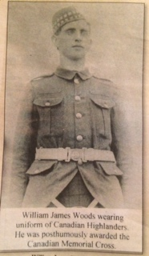

William married Annie Maria McGahey on the 26th Aug 1914 in Toronto, York, Ontario, Canada

He joined the Royal Canadian Highlanders, 15th Btn. Canadian Infantry Regimental Number 27832 and disembarked later in France. He died aged 24 from gas poisoning on 2nd May 1915. We understand that this gas attack was one of the first in the war during the battles around Ypres. He is buried at Hazebrouck Cemetery in Belgium. We have seen his last letter home dated 17th March 1915 and it makes very poignant reading.

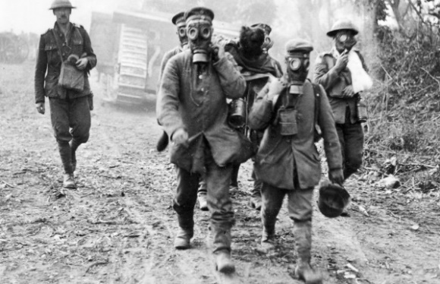 His widow was awarded the Canadian Memorial Cross, this is an award assigned to up to two nearest relatives by the serviceman in event of death on active service. Later increased to 3 nearest relatives.

James William Woods

Ontario Marriages, 1869-1927

|  |  |
| --- | --- |
| Name: | James William Woods |
| Event Type: | Marriage |
| Event Date: | 26 Aug 1914 |
| Event Place: | Toronto, York, Ontario, Canada |
| Gender: | Male |
| Age: | 24 |
| Birth Year (Estimated): | 1890 |
| Father's Name: | [Arthur Woods](https://familysearch.org/ark:/61903/1:1:278M-CG9) |
| Mother's Name: | [Francis Stewart](https://familysearch.org/ark:/61903/1:1:278M-CGS) |
| Spouse's Name: | [Annie Maria Mcgahey](https://familysearch.org/ark:/61903/1:1:278M-CG3) |
| Spouse's Gender: | Female |
| Spouse's Age: | 26 |
| Spouse's Birth Year (Estimated): | 1888 |
| Spouse's Father's Name: | [John Mcgahey](https://familysearch.org/ark:/61903/1:1:278M-CGQ) |
| Spouse's Mother's Name: | [Sarah Coulter](https://familysearch.org/ark:/61903/1:1:278M-CG7) |

During World War I, the Second Battle of Ypres was fought from 22 April – 25 May 1915 for control of the strategic Flemish town of Ypres in western Belgium after the First Battle of Ypres the previous autumn. It was the first mass use by Germany of poison gas on the Western Front.[Wikipedia](https://en.wikipedia.org/wiki/Second_Battle_of_Ypres)

[**Dates**](https://www.google.co.uk/search?q=second+battle+of+ypres+dates&stick=H4sIAAAAAAAAAOPgE-LUz9U3MCo0zjXXEshOttJPLUvNKym2SkksSS0GAE1PFqEfAAAA&sa=X&ved=2ahUKEwiI3q-M-_fdAhVDC8AKHQ-xAicQ6BMoADAdegQIBhAn)**:**22 Apr 1915 – 25 May 1915

[**Location**](https://www.google.co.uk/search?q=second+battle+of+ypres+location&stick=H4sIAAAAAAAAAOPgE-LUz9U3MCo0zjXXEs5OttJPLUvNKym2yslPTizJzM8DAFtrqFEiAAAA&sa=X&ved=2ahUKEwiI3q-M-_fdAhVDC8AKHQ-xAicQ6BMoADAeegQIBhAq)**:**[Ypres, Belgium](https://www.google.co.uk/search?q=Ypres&stick=H4sIAAAAAAAAAOPgE-LUz9U3MCo0zjVXAjMNTUzj47WEs5Ot9FPLUvNKiq1y8pMTSzLz8wAAxQUqLQAAAA&sa=X&ved=2ahUKEwiI3q-M-_fdAhVDC8AKHQ-xAicQmxMoATAeegQIBhAr)

[**Result**](https://www.google.co.uk/search?q=second+battle+of+ypres+result&stick=H4sIAAAAAAAAAOPgE-LUz9U3MCo0zjXXUsgot9JPzs_JSU0uyczP008tS80rKbYqSi0uzSlRKEosBwDkqqxTLwAAAA&sa=X&ved=2ahUKEwiI3q-M-_fdAhVDC8AKHQ-xAicQ6BMoADAfegQIBhAu)**:**Inconclusive

[Combatants](https://www.google.co.uk/search?q=second+battle+of+ypres+combatants&stick=H4sIAAAAAAAAAONgFuLUz9U3MCo0zjVXQjC1dDLKrfST83NyUpNLMvPz9HMzczJLEosq45Pz89JyMpNLiq2S83OTEksS80qKAQtcVHJGAAAA&sa=X&ved=2ahUKEwiI3q-M-_fdAhVDC8AKHQ-xAicQMSgAMCB6BAgGEDA)

[View 2+ more](https://www.google.co.uk/search?q=second+battle+of+ypres+combatants&stick=H4sIAAAAAAAAAONgFuLUz9U3MCo0zjVXQjC1dDLKrfST83NyUpNLMvPz9HMzczJLEosq45Pz89JyMpNLiq2S83OTEksS80qKAQtcVHJGAAAA&sa=X&ved=2ahUKEwiI3q-M-_fdAhVDC8AKHQ-xAicQzTooATAgegQIBhAx)

**C:\Users\John\AppData\Local\Microsoft\Windows\INetCache\Content.MSO\229FDE29.tmpC:\Users\John\AppData\Local\Microsoft\Windows\INetCache\Content.MSO\16FFA185.tmpC:\Users\John\AppData\Local\Microsoft\Windows\INetCache\Content.MSO\4CF1268D.tmp**

[France UK Germany](https://www.google.co.uk/search?q=France&stick=H4sIAAAAAAAAAONgFuLUz9U3MCo0zjVXAjPTLHIsk7VMPfLTyzNzUnwzczJLEosqnfPz0nIyk0uKnfNzkxJLEvNKikPyEZJQMQDQwxrETwAAAA&sa=X&ved=2ahUKEwiI3q-M-_fdAhVDC8AKHQ-xAicQxA0wIHoECAYQNA" \o "France)

**[C:\Users\John\AppData\Local\Microsoft\Windows\INetCache\Content.MSO\9771CB1F.tmpC:\Users\John\AppData\Local\Microsoft\Windows\INetCache\Content.MSO\8EFE8523.tmp](https://www.google.co.uk/search?q=Belgium&stick=H4sIAAAAAAAAAONgFuLUz9U3MCo0zjVX4gAxDU1NsrRMPfLTyzNzUnwzczJLEosqnfPz0nIyk0uKnfNzkxJLEvNKikPyEZJQMQCvUdGcTgAAAA&sa=X&ved=2ahUKEwiI3q-M-_fdAhVDC8AKHQ-xAicQxA0wIHoECAYQNg" \o "Belgium)**

[Belgium Canada](https://www.google.co.uk/search?q=Belgium&stick=H4sIAAAAAAAAAONgFuLUz9U3MCo0zjVX4gAxDU1NsrRMPfLTyzNzUnwzczJLEosqnfPz0nIyk0uKnfNzkxJLEvNKikPyEZJQMQCvUdGcTgAAAA&sa=X&ved=2ahUKEwiI3q-M-_fdAhVDC8AKHQ-xAicQxA0wIHoECAYQNg" \o "Belgium)

It’s timely to remember the first Canadians who had to deal with chemical weapons — the soldiers of the First Canadian Division in the second battle of Ypres on April 22-24, 1915.

The Canadians had the bad luck to be situated smack dab in the middle of the first poison gas attack in history. After several days of intense fighting, 6,000 soldiers — half the Canadian force — were dead, wounded, or taken prisoner of war. But, against all odds, they had beaten back a vastly bigger German army, holding their ground in the face of chlorine gas and withering fire.

It all changes at 4 p.m. on April 22, when the Germans launch operation “Disinfection.” A furious bombardment is followed by the release of 160 tons of chlorine gas from 5,730 canisters. The green-grey gas is spread more than six kilometres wide and almost a kilometre deep. It hits the French and Algerian lines first and hardest causing instant pandemonium. They fled leaving a 4 mile gap in the line. Fortunately the German soldiers were unwilling to enter the gas even in their equipment and the British and Canadians went in with a gallant charge to protect the front and saved the day.