17005 Rifleman Albert Smith
14th Btn Royal Irish Rifles, 109th Brigade, 36th Division
(Young Citizens) Disbanded February 1918.

17005 Rifleman Albert Smith enlisted in the 14th Btn Royal Irish Rifles which served in the 109th Brigade of the 36th Ulster Division and was killed in action, on the 16th August 1917. Rifleman Albert Smith was aged 22 years, at the Battle of Langemarck, and has no known grave. At that time his brother John was also on active service.

Albert is remembered on Panels 138 to 140 & 162 to 163A Tyne Cot Memorial, Belgium, Bangor and District War Memorial, Royal British Legion (Bangor Branch), Comrades of the Great War (Bangor Branch) Album in North Down Musuem, Wesley Centenary Methodist Church, Bangor and the Family Headstone in Bangor Cemetary, Newtownards Road, Newtownards.

Albert Smith was born around 1895/96 in Partick, Lanarkshire and he was a son of John and Elizabeth (Lizzie) Smith (nee Haddock, sometimes Haddick) who lived at 20 Lonsdale Street in Belfast and then at 94 Hamilton Road in Bangor.

John Smith worked as a master boot-maker and he and Lizzie had at least 10 children.
Edith b 1893/94 and Albert b 1895/96 in Partick, Lanarkshire.
John b 17 July 1897 Maze, Lisburn.
Elizabeth (Lizzie) b 19 Nov 1899 at 22 Duncrue St, Belfast,
Lucinda b 26 Jun 1902.
Sarah b 9 Jun 1902, and
Etheline b 27 Jul 1906 at 2 Melrose St, Belfast.
George b 10 Aug 1908 at 22 Antrim Road, Belfast.
Edward b 9 Oct 1911 at Lonsdale St. Belfast.
Allan b 3 Apr 1914 at 94 Hamilton Road, Bangor.

John Smith was proprietor of the Belfast and Glasgow Boot Repairing Company and prior to the outbreak of the Great War, Albert was working as an apprentice boot-maker with his father.

Albert’s John died on the 16th November 1919 and his mother on Elizabeth on 13th May 1939.

Campaign Medals:
Victory Medal
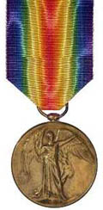
With the information in Albert Smith's record, it is likely that they were entitled to the Victory medal, also called the Inter Allied Victory Medal. This medal was awarded to all who received the 1914 Star or 1914-15 Star and, with certain exceptions, to those who received the British War Medal. It was never awarded alone. These three medals were sometimes irreverently referred to as Pip, Squeak and Wilfred.
Eligibility for this award consisted of having been mobilised, fighting, having served in any of the theatres of operations, or at sea, between midnight 4th/5th August, 1914, and midnight, 11th/12th November, 1918. Women who served in any of the various military organisations in a theatre of operations were also eligible.
Buy Medals

British War Medal
With the information in Albert Smith's record, it is likely that they were entitled to the British War Medal for service in World War One. This British Empire campaign medal was issued for services between 5th August 1914 and 11th November 1918.
The medal was automatically awarded in the event of death on active service before the completion of this period.
Buy Medals

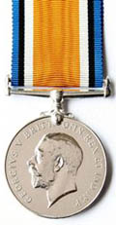
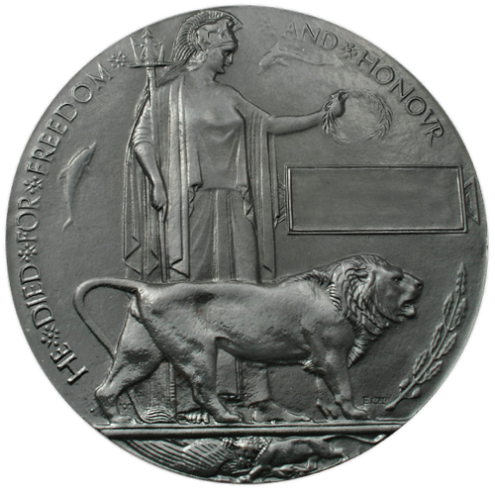
Memorial Death Plaque Of WWI
The next of kin for Albert Smith would have been sent this death plaque after the war to commemorate all of the war dead. Over 1 million were issued in total.
Buy Medals

