B/1828 Rifleman John Savage
8th Btn. The Rifle Brigade.

John was the son of John and Elizabeth Savage of Salford. He was also the husband of Jane Savage of 4 Seddon St, Ordsall Lane, Salford, Manchester.

B/1828 Rifleman John Savage enlisted in the 8th Btn the Rifle Brigade and served initially in India. He was killed in action, on the 19th August 1915 and was aged 47 years at the time of his death. He is buried at Potijze Burial Ground Cemetery, Ypres, Belgium, with the inscription “Too dearly loved to be forgotten by his Dear Wife and Loving Children. RIP.”

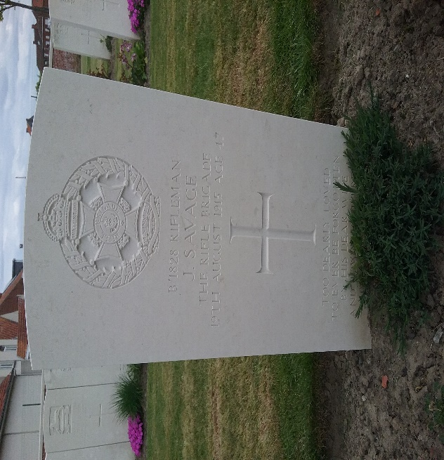
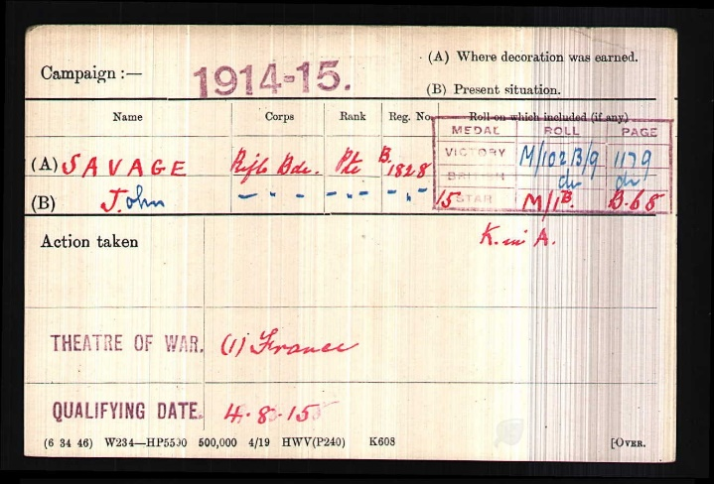

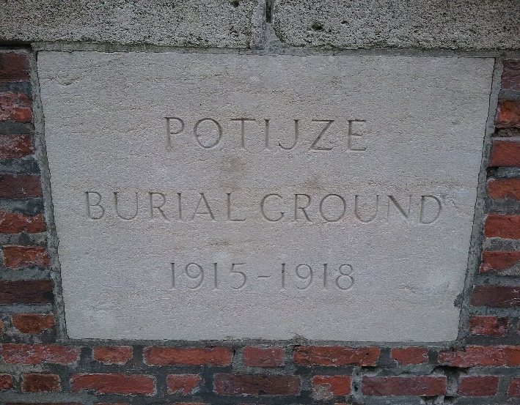

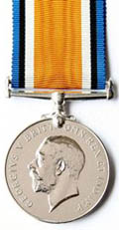
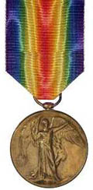
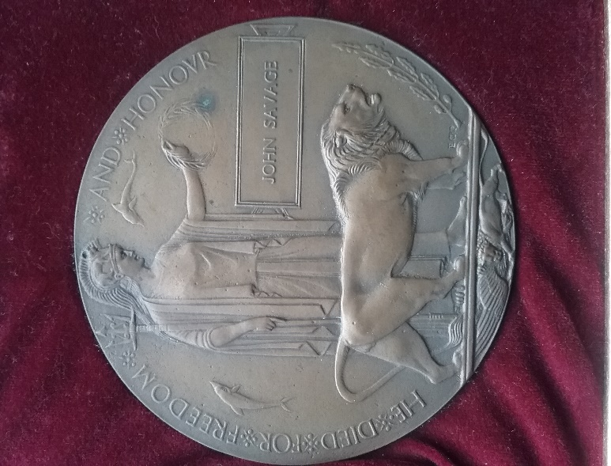

Campaign Medals:
Victory Medal
With the information in John Savage’s record, it is likely that they were entitled to the Victory medal, also called the Inter Allied Victory Medal. This medal was awarded to all who received the 1914 Star or 1914-15 Star and, with certain exceptions, to those who received the British War Medal. It was never awarded alone. These three medals were sometimes irreverently referred to as Pip, Squeak and Wilfred.
Eligibility for this award consisted of having been mobilised, fighting, having served in any of the theatres of operations, or at sea, between midnight 4th/5th August, 1914, and midnight, 11th/12th November, 1918. Women who served in any of the various military organisations in a theatre of operations were also eligible.
Buy Medals

British War Medal
With the information in John Savage’s record, it is likely that they were entitled to the British War Medal for service in World War One. This British Empire campaign medal was issued for services between 5th August 1914 and 11th November 1918.
The medal was automatically awarded in the event of death on active service before the completion of this period.
Buy Medals

Memorial Death Plaque Of WWI
The next of kin for John Savage would have been sent this death plaque after the war to commemorate all of the war dead. Over 1 million were issued in total.

