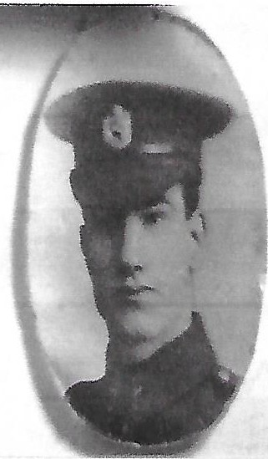Richard Phayre Eric Grenville 1896-1915 (Elizabeth's great uncle)

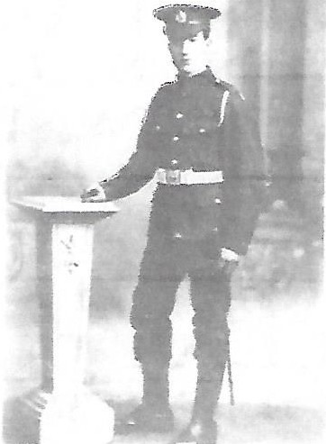

RPE served as Sapper No. 856 (possibly 858 ) in the First London Field Company, Royal Engineers. He was killed in the Great War on 9 Aug 1915 at Hooge. The story went that he was shot in the head by a German Officer. A telegram was sent to RPE's father Richard informing him of RPE's death. We know that the telegram was passed on to Harold Ernest Grenville, but it did not survive to be passed
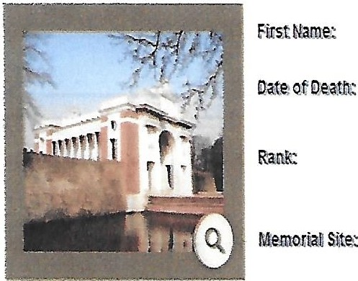
on. Richard's comrades said that they buried him in Sanctuary Wood, Flanders , but he was never found. His name is inscribed on panel 9 of the Menin Gate in Ypres Belgium along with the names of 54,000 other personnel for whom there are no known graves.

Granville

1 Covent Garden St Paul 2
Menin Gate Ypres.

Royal Engineers

1/1LonField Coy

At the end of July1915 the Germans had attacked the British Line at Hooge in the Ypres salient using liquid fire or
flame throwers and had captured part of the British Line as well as the large mine crater there. The British were
determined to regain control of these positions and their chance came early in August 1915 when 18 and 16 Brigade
of 6th Division launched an attack with the objective of doing just this. In the early hours of 9th June 1915 after a short
sharp artillery bombardment the attack went in. 18 Bde attacked from the south with 2nd Durham Light Infantry and
2nd Sherwood Foresters in front and 1st East Yorkshire in support. 16th London and 1st West Yorkshire were in reserve
16 Brigade attacked from the south-west, 1st Shropshire Light Infantry and 2nd York and Lancaster charged in side by
Side with 1st East Kent (Buffs) in support. For once the attack was a complete success. The German trenches were
soon taken and the two Brigades joined up in the crater. The whole 700 yards of the front lost a week earlier was
regained and the Germans suffered heavy casualties as well as 130 men taken prisoner. The new positions were
quickly consolidated and a German counter attack repulsed, but there were a number of casualties among the 1st.
London Field Company of the Royal Engineers whilst they were rewiring.

