Grenville family WWl connection

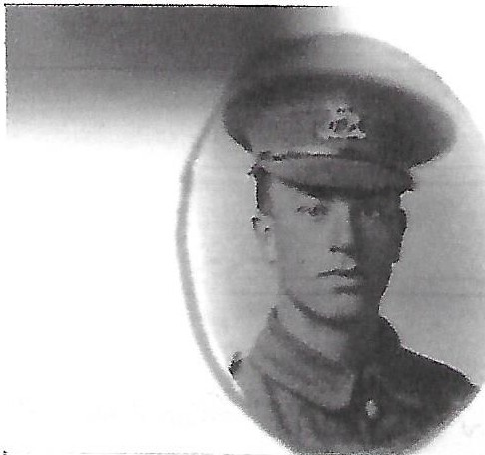
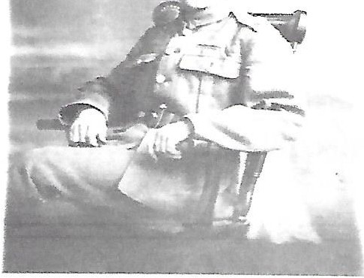
Harold Ernest Grenville 25-9-1897 -11-6-1978 (Elizabeth's Grandfather}

=-

Harold enlisted in the Royal engineers at the age of 17 ½ in 1914 and served in France and Belgium, he survived the war and was subsequently posted to Ireland in 1918.
Harold served in the Special Constabulary in Ireland from 3rd April 1922 to 26th March 1926. He was Registered Number S/6483 and held the rank of S/Constable - Crossley Driver when disbanded. He was described on official papers as Age 28, 5'6" high, slight build, hazel eyes and of "very good" general conduct.
In 1939 Harold re-joined the army and served until the end of the Second World War.

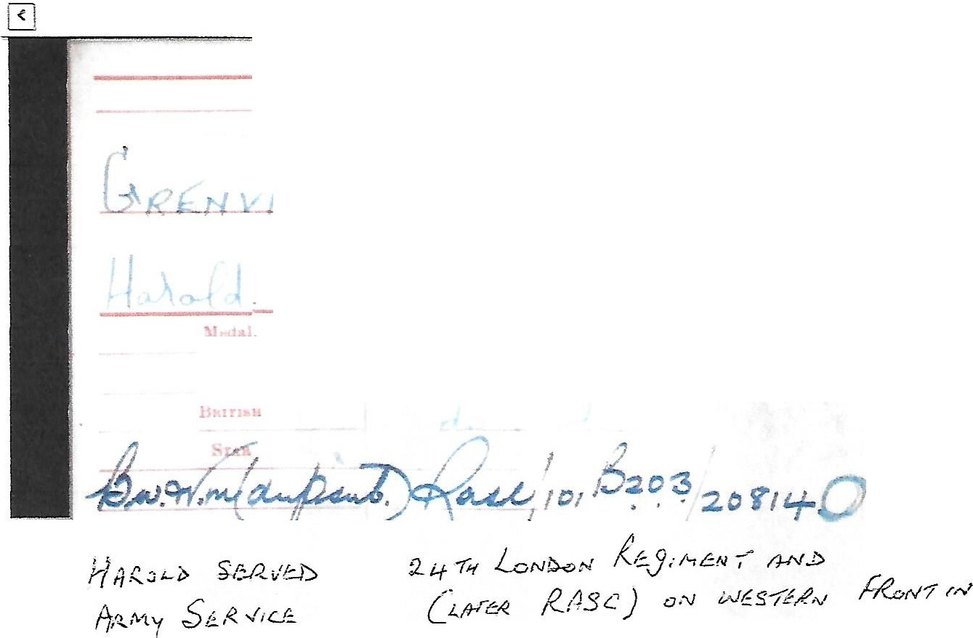
Na.me
_J
;
.t.
... -
I
•
1,
l arks.
\ at
in
Corps/) 1,J5·
-
WW1

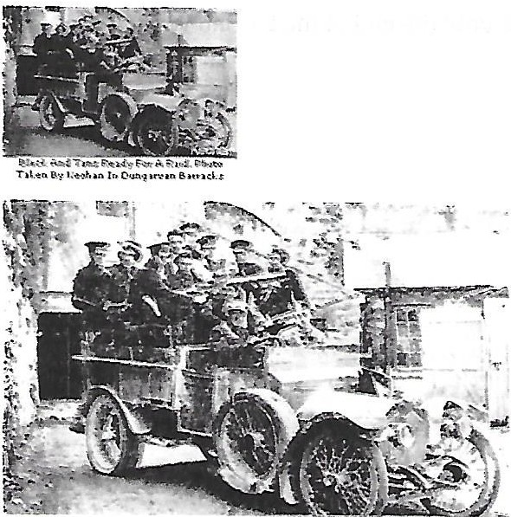
Served as Private

3789 in London Regiment
And 721348 in Army Service Corps.

Crossley Armoured Tenders in close proximity to Royal Irish Special Constabulary Barracks during the 1920’s.
Similar to the type driven by Harold in Ireland between the wars.

.

