Private Robert McKee 120613 Royal Army Service Corps

Born 1894
Like many thousands of other young men, after war broke out in 1914, Robert McKee joined the 36th Ulster Division as a Private. After basic training he became an ambulance driver. He can be seen in this photograph in his uniform, standing beside his vehicle with the large red­
cross emblazoned on the side.
He was lucky to come through the war unscathed and received an official letter of thanks signed by Major-General Boyce, Director of Transport of British Armies in France.
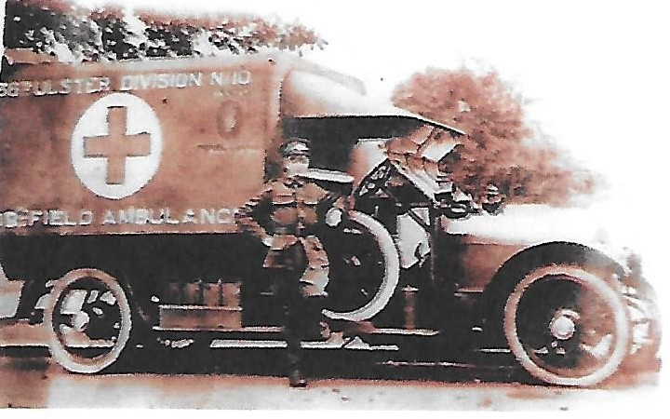

.

Pull Over! It’s an Emergency!:

World War I Ambulance Drivers

If you’ve ever driven in the city, then you are certainly familiar with the jarring sound of an ambulance on an emergency run. The loud wee-woo-wee-woo, in concert with rotating red lights, evoke a sense of urgency that causes you to instinctively check your mirrors and pull over—making way for the vehicle that just may be the link between life and death for some poor soul nearby. If you’ve ever ridden inside of one, strapped to a gurney with your neck in a brace after a car accident, as was I a few years ago, then you probably have an elevated sense of awareness, respect and gratitude for the people who drive them. Before then, I had never given them much thought. I just tried to stay out of their way.
Ambulances were still considered high-tech during World War I. This marked the first major conflict in which automobiles could be utilized to move the wounded and dying. Now, countless lives that would have otherwise been lost on the battlefield could be saved. Driving an ambulance enabled Americans to participate in the war before the official entrance of the United States in 1917; it also gave younger Americans, who were not yet 18, an opportunity to participate, as well as those who might have supported the Allies, but did not want to serve in a combat role.

World War I
During World War One, the Red Cross brought in the first widespread battlefield motor ambulances to replace horse-drawn vehicles, a change which was such a success, the horse-drawn variants were quickly phased out. In civilian emergency care, dedicated ambulance services were frequently managed or dispatched by individual hospitals, though in some areas, telegraph and telephone services enabled police departments to handle dispatch duties.
The equipment carried by the ambulance was changing fast at this time. Traction splints were introduced during World War I, and were found to have a positive effect on the morbidity and mortality of patients with leg fractures. Two-way radios became available shortly after World War I, providing more efficient radio dispatch of ambulances. Shortly before World War II, then, a modern ambulance carried advanced medical equipment, was staffed by a physician, and was dispatched by radio. It was frequently found that ambulances were hearses – the only available vehicle that could carry a recumbent patient – and were thus frequently run by funeral homes. These vehicles which could serve for either purpose were known as combination cars.

