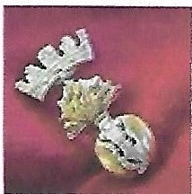
Marador WWl Research Services
Irish Divisions and Regiment s during the Great War

Thomas John Bell - 13th Btn Royal Irish Rifles

Audio: Green Fields of France - The Fureys and Davey Arthur
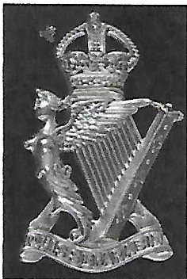

Cap Badge - Royal Irish Rifles

Rifleman ThomasJohn Bell - Service No.16230 C.Company,13th Battalion, Royal Irish Rifles.
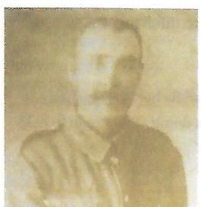

Thomas John Bell

(Acknowledgement - contains extracts from Dromore's Great War Heroes by Jeffrey Martin B.Sc (Hons )

Thomas, son of John and Martha Bell of Ballyvlcknakelly, was born in Dromore, County Down on the nth May 1878. He had two sisters Agnes and Mary.
Hewas employed as a Railway Porter for the Great Northern Line in Dromore.
He was a member of Dromore Cathedral Church, Orange Order Ballynavicknakelly LOL No.828, No.11Royal Black Preceptoryand Dromore Masonic Lodge No. 70.

His sister Agnes Sarah was married to Robert James Martin and Thomas wasstaying with her in Mount Street, Dromore at the time of the 1901 census, while Robert was in the Boer War, to helpher and her twoyoung children Thomas Neill Martin and Mary Minnie Martin.

Thomaswas an old member of the South Down Militia and took an active part in thetraining of the local Ulster Volunteer Force in Dromore. As one of its founding members, when the call came he set off from Dromore Railway Station with the rest of the company on the 19thSeptember1914for Clandeboye Camp. He enlisted into the First County Down Volunteers, later to be called the 13thBattalion, the Royal Irish Rifles.

In the Somme sector prior to the fateful ist July1916 the 13th Battalion Royal Irish Rifles and the 9th Battalion Royal Irish Fusiliers werebilleted in a village called Rainneville , but it was too small to accommodate both so the 13th moved to a village called St. Gratien about 4 miles behind the front line. On the 28th June1916 the 13th were moving to the front line to relieve the 11th Battalion Royal Irish Rifles by platoons and as the last platoon in CCompany formed up to march off, a German shell hit them and the explosion killed 14 outright with another 7 dying the next day.

The 14killed that daywere the first burials in the new British Military cemetery at Martinsart. Thomas Bell is interred in Plot1, RowA, Grave1. Alongside his comrades many of whom were from Dromore County Down.
If we borrow the first verse of the very moving song "Green Fields of France" about the Somme and adapt it as follows

Well how do you do (Thomas John Bell)
Do you mind if I pause by your graveside to dwell And rest for a while, 'neath the warm summer sun I've been walkingallday, and I'm nearly done.
I see by your gravestone, eight and thirty you've been When you joined the great fallen in1916.
I hope you died well, and I hope you died clean, Or,Thomas John Bell, was. it slow and obscene? Chorus:
Did they beat the drum slowly, did they play the fifelowly ? Did they sound the Dead March as they lowered you down ? And did th e band play The Last Post and chorus ?
Did the pipes.play the Flowers of the Forest ?

At least we know in Thomas' case it was instant and clean as thisletter to his parents from Sgt. Willie Henderson states:

"Yourson was killed by the explosion of a shellwhile parading with his platoon in the early hours of the morning of 28th June before going up to the tre.nches to take part in the terrible battle of 1st July. He was spared that awful ordeal. The sameshell killed a good many others on parade also.The scene of this wasthe village street about four miles behind the front-line. I maytell you that they were all buried side bysidein a nice little cemetery clos.e to where they were killed.Their graves are kept in good order byBritish soldiers appointed for that purpose.

Personally I may tellyou that I knewyour son better than any man in the battalion, as he and I spent most of our time together.We lived like two good chums and we never had any trouble. I trusted himentirely and always found himstraight and I can tell you that he waspreparedto meet his God as, all the tim e we lived together he never lay down at night without saying his prayers and on the last night wewere together in our little billet he spent a long time reading his prayer book

I dofeel for you very much, s.eeing he was your only son, andsuch a good boy. It is only thosewhohave lost a loved one can feelfor others. I myself lost my owndear son at the Dardanelles (Gallipoli) therefore my truest sympathy goes out to you in your terrible loss. In conclusion I hope that God may give you stren gth to bear yourburden, remembering that your son died for his King, Country, You and everyone at home."

His nephew Tommy Martin would have worked on the very trenches thatThomas was about to enter andit would be nice to think they might have met in France as Tommy's unit the16th Battalion Royal Irish Rifles were the Pioneers for the Ulster Division.

!twas astrange chain of events that in1901Thomas Bell was helping his sister AgnesSarah lookafter the infant Tommy while her husband Robert Ma.rtin was at the Boer War and in 1916Tommy Martin as a Pioneer working on the tr enches.and defensive protection was doing all he could to help keep his uncle Thomas safein theTrenches during the Great War.

Marador WW! Research SPrvires Privary Poliry Proudl;•powered by WorclPress

