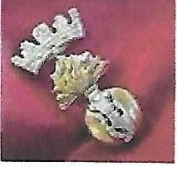
Marador WWl Research Services
IrishDivisions andRegiments during the Great War

Thomas Neill Martin - 16th Btn Royal Irish Rifles (Pioneers)

Audio: Highland Cathedral - Band of the Royal Scots Dragoon Guards
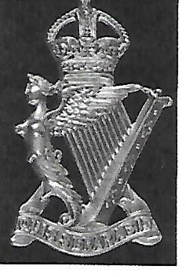

Cap Badge - Royal Irish Rifles

Rifleman Thomas Neill Martin - No.16/124 and 648737 16th Battalion Royal Irish Rifles and Labour Corps (Sep.1918)
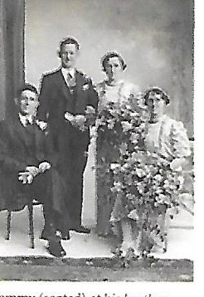
Tommi•(seated) at his brother Robert's\r edding in Septemfxor 1937. (Strabane )

Tommy seated at his brother'swedding.
Thomas Neill Martin, eldest son of Robert James Martin and Agnes Sarah Bell was born in Dromore, County Down on the 29th May1897.He had one younger brother also called Robert Jame s and 3sisters Minnie, Agnes Sarah and Ellen Ann.
His father was a BoerWarveteran and the1901census discl oses that his uncleThomas John Bell washelping his sister look after young Tommy and Minnie whilst their father was in South Africa.
Thomas John Bell waslater to be killed just a few daysbefore the Battle of the Somme in WW1not far from the relative safety of trenches his nephew had probably helped to construct.

Tommy enlisted in the call to arms on the 7th November 1914, joining the Second County Down Volunteers in Lurgan on the 14th November. Thiswas later renamed as the 16th {Service) Battalion, Royal Irish Rifles (Pioneers) acting in the main role of Pioneer Battalion for the 36th (Ulster) Division.

His Regimental number was16/124 but I do not know to which Company, Section or Platoon he was allocated. However I know he served with that Battalion throughout the First World War until early September 1918, when he was transferred back to England in the Labour Corps (Number 648737)

From Jeffrey Martin (author of Drornore's GreatWar Heroes), " The DromoreWeekly Times photocopy (for the following Saturday 21st November
1914) details a T.Martin (Mount Street) who enlisted that sameweek.I crosschecked the article that Icopied when the T.Martin medals were for sale and low and behold he is number16-124! He was in the queue 22 places in front of my grandfather ( Sgt.Walter Martin). As I have a keen interest in the16th Bn RIR, I knowfor a fact that menwith these lownumbers joined on the first day,in the second to third week of November, because by
Christmas1914 numbers were up to about 800 and they imported 14th Bn RIR men in Jan and Feb 1915 to bolster Battalion numbers to the uoo
establishment."
His medals are the 1914-15Star, BritishWar Medal, Victory Medal, Special Constabulary Long Service Medal (EIIR) "Ulster" and a Battle of the Somme CommermorativeMedal.

The Special Constabulary "Ulster" Medal is a rare medal on its own.
The fact that the word "Ulster" appears on the reverse of Tommy's Special Constable Medalindicates it was issued on or after1956, and thatThomas Martin saw service with the Crown during a period of over 40 years"

TheSomme Commemorative medals were only given to veterans, returning to the Somme who fought there in1916 or 1940 (WW2) - in his case WW1 obviously- often on specialoccasions sucll as the 40th or 50th anniversary (1956 or 1966) and indeed there were evensome in 1976 for the few remaining veterans,

In the detailslisted with the medals it says that hewastransferred to the Labour Corps (thisgenerally indicates the man was wounded or incapacitated even byshellshock etc), able to dosome work but not fit for front lineduty. His Labour Corps number is 648737. He wasalso given whatwas.known as a Silver War Badge, this wasso that when you went homeyou could wear it on your civilian clothes to show you had served and were injured and not "a shirker" as some would say. Hewas discharged on 27th November 1918. Though the war was over,it wasstill important to wear it.
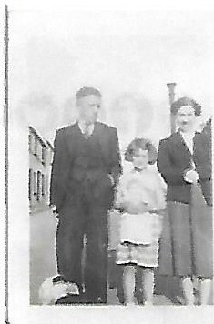
Tommy with his daughter J\1artha and granddaughter Ma rie, about 19 2

Mariewas about 6 years old in the above photo.

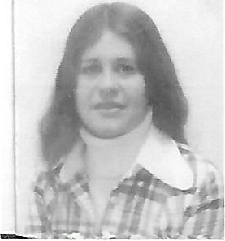

Marie in Rirnini, Italy1969aged 23.

I met and Married Tommy's granddaughter Marie in 1962and got to know Tommy for a few years.I never spoke to him about the past and he rarely mentioned the war years like many of his generation.

Tommy died on tlie 8th September1969 and regrettably Marie and I were on holiday in Italy during my tour of duty in Germany at the time, so she never had a chance to say goodbye to her dearly loved Granddad.

Marie diedon the 26th April1991- one day after her olderson Martyn's18thbirthday.
NeitherMarienor Tommy got to see the grandchildren for whom I have written a summary of the Battalion's experiences from 1914to 1919. John Doran
13th April 2016

