Joseph Hamilton 9th (North Irish Horse) Royal Irish Fusiliers
(Formerly known as Blackers Boys)

Joseph was born on 30th August 1893 to his father William Hamilton and his mother Sarah Hamilton nee Davis. His family lived in Brownlow Terrace, Lurgan, during the 1901+1911 censuses having 11 children in total by the 1911 census. Older members of the family worked in the linen industry and Joseph as a Linen Warper Yarn. Joseph was a member of A Platoon, Lurgan, Ulster Volunteer Force and of Royal Black Perceptory, Rising Sun, 108. He married Sarah Lyttle on the 23rd June 1915. Sarah died on 4th February 1918 from heart failure in Lurgan. Joseph enlisted in the 9th Btn. Royal Irish Fusiliers in 1914. He was a Bangalore Torpedo specialist and they were carried forward by the attacking soldiers and used to cut a path through wire. After the attack of 1st June 1916 he was promoted Corporal and by 1918 had achieved the rank of Company Sergeant Major (WO2). He was killed in action, close to the end of the war, on 25th October 1918 at Anseghem, Belgium and is buried at Harlebeke New Cemetery, West-Vlaaderen, Belgium. He is named on the war memorial in Lurgan, Co. Armagh. Entry also inserted by the Officers and Member of RBP 108 for Sir Knight and Brother Joe Hamilton, Royal Irish Fusiliers.
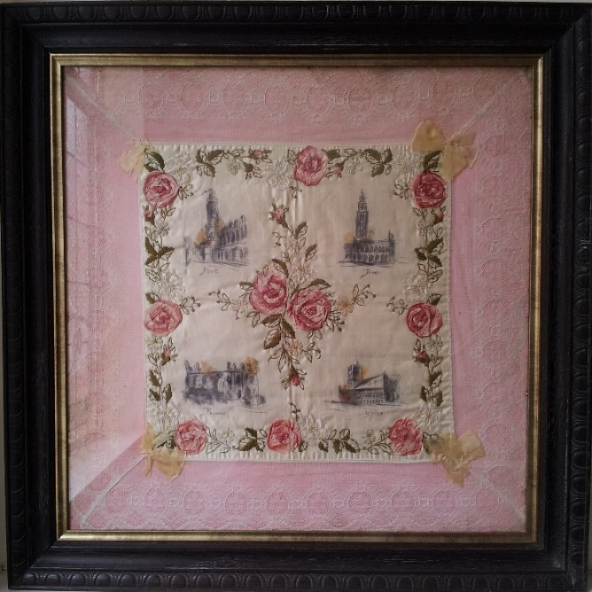
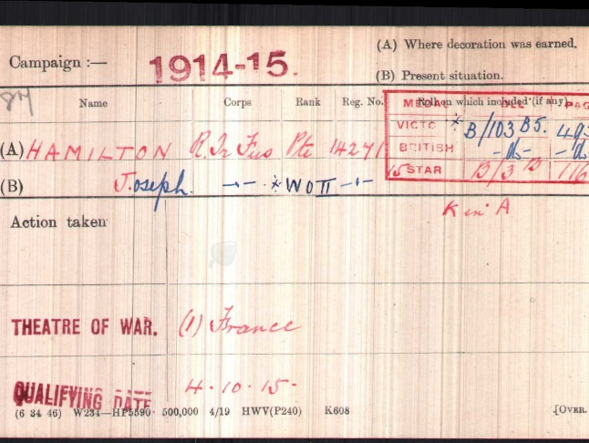

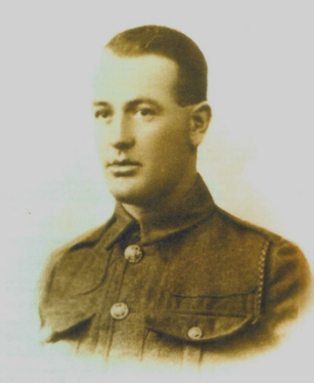

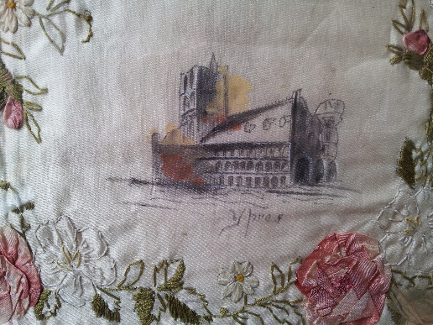

Company Serjeant Major Joseph Hamilton (Royal Irish Fusiliers)
died 3 months later on 25/10/1918, aged 26 - days before armistice.
Letters from Joe to his mum.

Just a few lines to let you know I am doing well and in the best of health, hoping you are the same, and also father too.
You can tell all at home I was asking for them, not forgetting uncle Joe. I hope he has got over his sickness again and father too.
Well Mother I am sorry to hear of uncle Tommy being dead. I had a letter from Sadie telling me about his death. Mother, he is better done for than standing any hardships as he has done, poor old Tommy, I hope he is in heaven. I hope the Lord was good to him and did not keep him suffering any pain for he was a good old man, only for that cursed drink.
Well Mother, I hope you took him to Shankill and had a good funeral, you can let me know in the next letter, I am sorry I was not at home to see him but all the other (times) I gave him a good talking too but it was no good to him, he had no sense.
Well Mother, how is Hanna, is she all right again? Let me know and I will write to her, did she and Charlie go and see Tommy? I hope all the rest are doing well and in good health, did uncle Joe get the two pipes I sent with the ship? I hope it will not be long till I hear from you and hope to see you soon.
Good luck, right.
I remain you loving son, Joe.
Sent you one of my photos in a\ lerrer to Sadie. She will send it round to you, it is not very good but it will do you all.
HAMILTON From Joe To Mother
Best love to all at home XXXXX
Tell Bob I was asking for him And tell him to mind himself.

Joe

